Systemic Anti-Cancer Therapy Regimen Data Standard
HISO 10080:2021
Published XX 2021

Te Aho o Te Kahu, the Cancer Control Agency is an independent departmental agency that was established to lead and unite efforts to deliver better cancer outcomes for Aotearoa.
Te Aho o Te Kahu develops and publishes cancer-specific data standards in partnership with the Health Information Standards Organisation (HISO).
Te Aho o Te Kahu and HISO acknowledge the many people and organisations who contributed to the publication of this data standard.

Citation: Te Aho o Te Kahu. 2021. HISO 10080:2021 Systemic Anti-Cancer Therapy Regimen Data Standard. Wellington: Te Aho o Te Kahu.
Published in <month> 2021 by Te Aho o Te Kahu, the Cancer Control Agency
PO Box 5013, Wellington 6140, New Zealand
ISBN xxx-x-xx-xxxxxx-x (online)
HP xxxx

This document is available at teaho.govt.nz and health.govt.nz
This work is licensed under the Creative Commons Attribution 4.0 International licence. In essence, you are free to: share ie, copy and redistribute the material in any medium or format; adapt ie, remix, transform and build upon the material. You must give appropriate credit, provide a link to the licence and indicate if changes were made.

Contents
1 Purpose 1
2 Scope 2
3 Background 3
3.1 Definitions 3
3.2 Legislation and regulations 4
3.3 Related specifications 4
4 Requirements 5
4.1 SNOMED CT 5
4.2 Character sets 5
4.3 Medicine concept specification 5
4.4 Data element template 6
5 Data elements 7
5.1 Regimen value set taxonomy 7
5.2 Regimen value sets 7
5.3 Regimen naming convention 19
5.4 Regimen SNOMED CT concepts 21
5.5 Unapproved medicines and unapproved indications 21
5.6 Use of numbers in dosage information documentation 21
5.7 Publication of regimens 22
5.8 FHIR API 22
5.9 Retention of discontinued and superseded regimens 22
5.10 Regimen creation and maintenance process 22
6 IMPLEMENTATION requirements 24
6.1 Adoption roadmap 24

Purpose
This document is a standard for the accurate and consistent identification and description of systemic anti-cancer therapy regimens in New Zealand.

Systemic anti-cancer therapy (SACT) refers to all drug treatments for cancer. This includes chemotherapy, targeted therapies, hormones and other drug therapies.

The standard originates from the project called SACT NZ at its launch in late 2018, which sets out to develop a detailed database of information on patients receiving systemic anti-cancer therapy across New Zealand, aiming to identify and reduce variation, enhance equity of access and support resource planning.

In 2020 the project was renamed ACT-NOW which stands for Anti-Cancer Therapy – Nationally Organised Workstreams. The project, in its first phase, requires the development of national data and regimen definitions to create a solid foundation for the subsequent capture of meaningful and comparable data at a national level.

Scope
The data standard covers treatment regimens for adult solid or haematological cancers developed under the auspices of the ACT-NOW project and software systems used to develop and manage those regimens.

This document identifies the mandatory data elements and code sets required to construct consistent, accessible and accurate SACT regimen definitions.

The standard does not cover:
- Adolescent and young adult cancer patients (AYA)
- Non-malignant bloods
- Clinical trials

While the standard currently excludes treatment regimens for paediatric cancers of all types and one-off regimens developed by individual clinicians, it is expected that any regimens eventually developed for these situations will comply with the standard.

Background
The New Zealand Cancer Action Plan | Te Mahere mō te Mate Pukupuku o Aotearoa 2019-2029 provides a pathway to improve cancer outcomes for all New Zealanders with the objectives of building a system that delivers consistent and modern cancer care, equitable cancer outcomes, fewer cancers and better cancer survival, supportive care and end of life care.

Te Aho o Te Kahu (Cancer Control Agency) is the independent departmental agency, reporting directly to the Minister of Health, charged with providing strong central leadership and oversight of cancer control in New Zealand.

The Anti-Cancer Therapy – Nationally Organised Workstreams (ACT-NOW) programme was launched in late 2018 to develop a detailed database of information on patients receiving systemic anti-cancer therapy across New Zealand and work with the medical oncology, haematology, pharmacist and nursing communities to identify and reduce variation, enhance equity of access and support resource planning.

The first phase of the ACT-NOW project requires the development of national data and regimen definitions to create a solid foundation for the subsequent capture of meaningful and comparable data at the national level. Linking this project with Whakamaua – Māori Health Action Plan 2020-25 will enable Te Aho o Te Kahu to coordinate action to achieve the aims of He Korowai Oranga – Māori Health Strategy.

The Cancer Health Information Strategy 2015 endorsed SNOMED CT as the required system of terminology for point of care applications. SNOMED CT must be the clinical terminology used to capture cancer health information at point of care.

All systems with medicines management functions are required to adhere to HISO 10024.1:2018 New Zealand Universal List of Medicines and New Zealand Formulary in order to be properly functional and interoperable in the digital health ecosystem.

Definitions
Term | Definition
Tumour group or stream | A group of similar or related cancers, usually categorised according to the bodily system or organ they are associated with (eg, bowel, gynaecological, breast).
SNOMED CT | Systematized Nomenclature of Medicine – Clinical Terms is a systematic, computer-processable collection of medical terms that provide definitions and synonyms that cover anatomy, diseases, findings, procedures, microorganisms, substances and so on. It is a consistent way to store, retrieve and aggregate medical data across specialties and sites of care.

Legislation and regulations
The following legislation and regulations are relevant to this standard:
- Medicines Act 1981 and Medicines Regulations 1984.

ACT-NOW regimens contain information about medicines. Clinical systems that use ACT-NOW regimens will record health information about individual people and the medicines administered to them during their care.

Related specifications
The following documents have been used to develop or are referenced in this standard.
- New Zealand Cancer Health Information Strategy. Wellington: Ministry of Health
- New Zealand Cancer Plan: Better, faster cancer care 2015–2018. Wellington: Ministry of Health
- New Zealand Cancer Action Plan 2019–2029 – Te Mahere mō te Mate Pukupuku o Aotearoa 2019–2029. Revised January 2020. Wellington: Ministry of Health
- HISO 10013:2015 HL7 Standards Endorsement
- HISO 10038.3 National Cancer Core Data Standard
- HISO 10042 Medication Charting and Medicine Reconciliation Standards
- HISO 10063:2017 GS1 Standards Endorsement
- HISO 10083:2020 Interoperability Roadmap

Requirements

SNOMED CT

Clinical terminology standard
Coded data elements in ACT-NOW regimens use by default the SNOMED CT terminology for clinical information. The concepts making up each value domain are denoted by either the preferred term or a clinically agreed term and are linked to entries in the SNOMED CT browser. The SNOMED CT concept identifier (SCTID) can be viewed by hovering over the link.

Some data elements are restricted to a definite set of SNOMED CT concepts, while others are more open-ended and allow the user to select from a wider set of concepts, usually within a certain hierarchy or sub-hierarchy eg, the set of all disease concepts.

See the SNOMED CT Search and Data Entry Guide for a guide to building a user-friendly search across the terminology.

Systems should display the SNOMED preferred or clinically agreed term and capture the SNOMED concept identifier accordingly.

The SNOMED NZ Edition, incorporating the SNOMED CT International Edition and released in April and October every year, is the standard distribution. SNOMED CT is free to use in New Zealand and easy to implement. Download and install each release from the Member Licensing and Distribution Service or integrate your software with the SNOMED CT terminology service provided by the Ministry of Health.

Character sets
Text data elements must accommodate macrons for te reo Māori and diacritic characters for other commonly used languages. By default, this means using the Unicode Basic Latin, Latin-1 Supplement and Latin Extended A character sets.

ISO/IEC 10646:2017 Information technology – Universal Coded Character Set (UCS) is the recognised standard. UTF-8 is the recommended character encoding.

Medicine concept specification
ACT-NOW cancer regimens specify medicines using the New Zealand Medicines Terminology (NZMT) Medicinal Product (MP) concept SCTID and Tall Man lettering preferred term.

Where the MP concept models a medicine that either:
- meets the requirements of the Health Quality & Safety Commission (HQSC) Medication Safety Expert Advisory Group’s Specify Brand Advice Guidance or
- the working group has objective evidence that available presentations of the medicine are not interchangeable in oncology practice.

The human readable format displayed to users in software systems will be «MP preferred term» «(Brand Name)».

Data element template
Data element specifications in this standard conform to the requirements of ISO/IEC 11179 Information Technology – Metadata Registries (MDR).

Definition | A statement that expresses the essential nature of the data element and its differentiation from other elements in the data set.
Source standards | Established data definitions or guidelines relating to the data element.
Data type | Alphabetic (A)  Date  Date/time  Numeric (N)  Alphanumeric (X)  Boolean | Representational class | Code, free text, value or identifier.  For date and time data types, use full date or partial date.
Field size | Maximum number of characters | Representational layout | The formatted arrangement of characters in alphanumeric elements, for example:  - X(50) for a 50-character alphanumeric string  - NNN for a 3-digit number  - NNAAAA for a formatted alphanumeric identifier.
Value domain | The named, enumerated or described set of valid values or codes that are acceptable for the data element.  Each coded data element has a specified code set.
Obligation | Indicates if the data element is mandatory or optional in the context, or whether its appearance is conditional.
Guide for use | Additional guidance to inform the use of the data element.
Verification rules | Quality control mechanisms that preclude invalid values.

Data elements

Regimen value set taxonomy
The value set taxonomy for ACT-NOW regimens is:
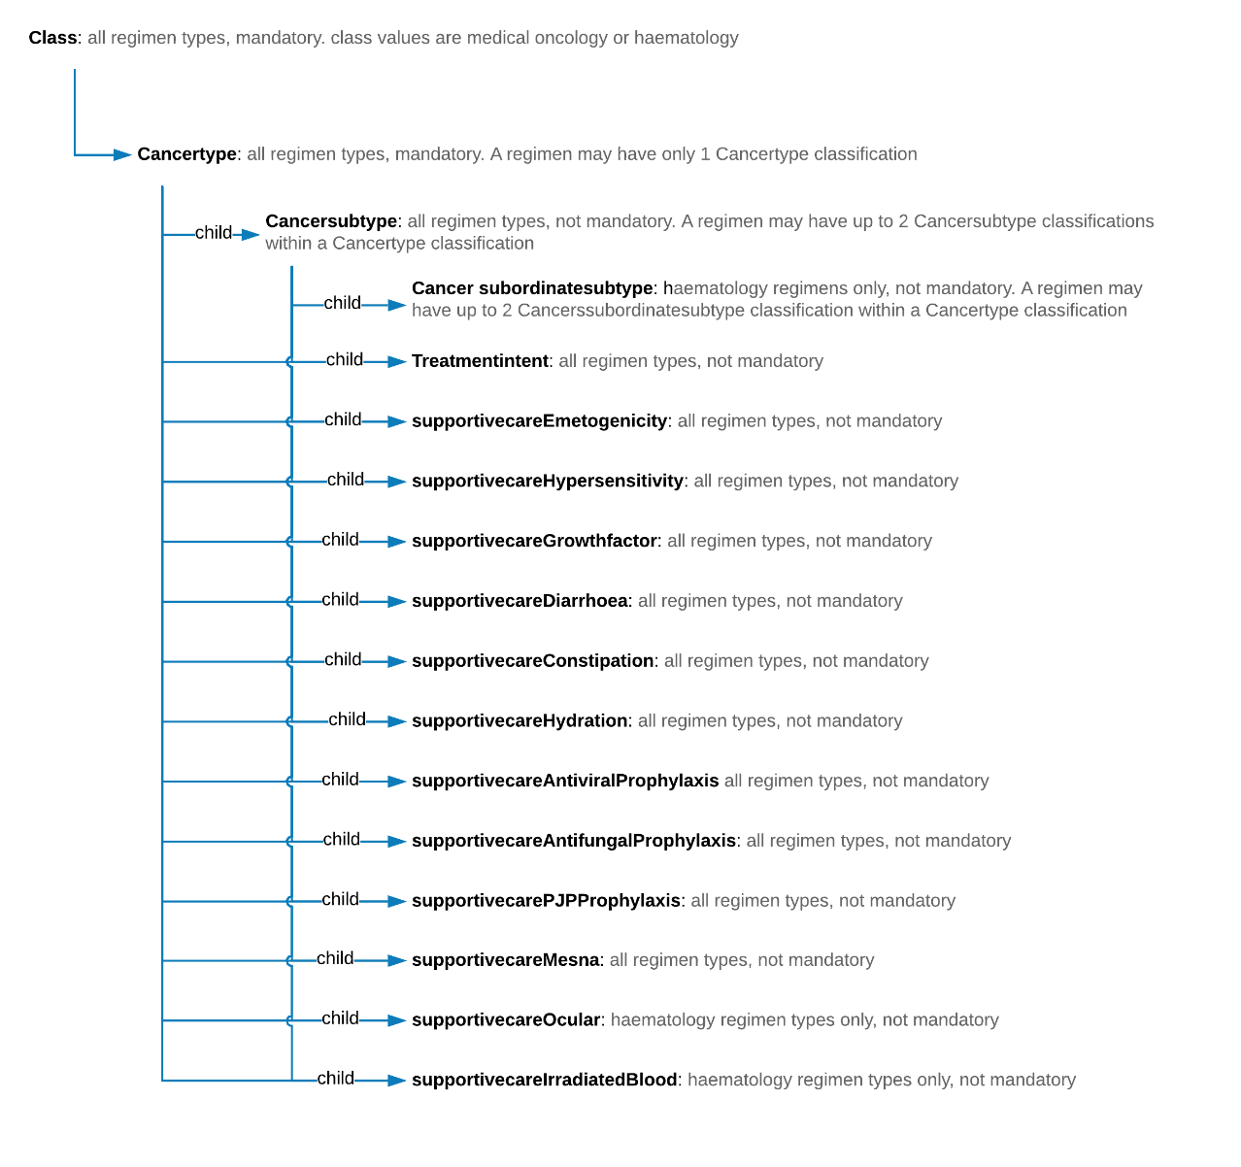

Regimen value sets

Cancer type
Note: Two values in the proposed list of permissible cancer types, being ‘marrow transplant’ and ‘blood and marrow transplant’ are terms from the SNOMED CT Procedure hierarchy. Work is currently underway to support collecting the relevant cancer types that would represent these two terms.

Definition | The taxonomy level that defines the body system group of cancers the regimen treats.
Source standards | SNOMED New Zealand Edition
Data type | Numeric | Representational class | Code
Field size | 18 | Representational layout | N(18)
Value domain | SCTID Display name  234336002 Blood and marrow transplant  254837009 Breast  781382000 Colorectal  363514001 Gynaecological  255056009 Head and neck  93143009 Leukaemias  118600007 Lymphoma  23719005 Marrow transplant  109989006 Multiple myeloma  372063002 Neurological  449096009 Respiratory  424413001 Sarcoma  372130007 Skin cancer  61331000210103 Upper gastrointestinal  271468000 Urogenital
Obligation | Mandatory
Guide for use | The permissible codes for cancer type in ACT-NOW regimens are derived from the malignant neoplastic disease branch of the SNOMED CT disease hierarchy.

Cancer subtype
Definition | The taxonomy level that defines the discrete cancer type from the body system group of cancers that the regimen treats.
Source standards | SNOMED New Zealand Edition
Data type | Numeric | Representational class | Code
Field size | 18 | Representational layout | N(18)
Value domain | SCTID Display name  91857003 Acute lymphoblastic leukaemia  91861009 Acute myeloid leukaemia  110004001 Acute promyelocytic leukaemia  363490009 Anal  254701007 Basal cell  363415003 Biliary  399326009 Bladder  448710000 Bone sarcoma  118617000 Burkitt lymphoma  363354003 Cervical  92814006 Chronic lymphocytic leukaemia  92818009 Chronic myeloid leukaemia  93781006 Endometrial  363349007 Gastric  420120006 Gastrointestinal stromal cell tumours  416402001 Gestational trophoblastic disease  393564001 Glioma  118613001 Hairy cell leukaemia  93870000 Hepatic  118599009 Hodgkin lymphoma  443487006 Mantle cell lymphoma  372244006 Melanoma  253001006 Merkel Cell  109378008 Mesothelioma  109995007 Myelodysplastic disorders  187692001 Nasopharyngeal  133531000119104 Neuroendocrine  254637007 Non-small cell lung cancer  118601006 Non-Hodgkin lymphoma  363402007 Oesophageal  363443007 Ovarian  363418001 Pancreas  307649006 Primary CNS lymphoma  399068003 Prostate  363351006 Rectal  363518003 Renal  255072001 Salivary gland  254632001 Small cell lung cancer  424952003 Soft tissue sarcoma  402815007 Squamous cell  363449006 Testicular  363478007 Thyroid  94125001 Urothelial  363367000 Vulval  190818004 Waldenstrom macroglobulinaemia
Obligation | Mandatory
Guide for use | The permissible values for cancer subtype in ACT-NOW regimens are derived from the neoplastic disease branch of the SNOMED CT disease hierarchy.

Cancer subordinate subtype
Definition | The taxonomy level that further defines the discrete cancer type from the body system group of cancers that the regimen treats according to cancer tissue characteristics or the cancer’s response to treatment.
Source standards | SNOMED New Zealand Edition
Data type | Numeric | Representational class | Code
Field size | 18 | Representational layout | N(18)
Value domain | SCTID Display name  427492003 Castration resistant  722103009 Castration sensitive  396198006 Small cell prostate cancer
Obligation | Optional.  Inclusion of the cancer subordinate subtype in the regimen description is conditional.
Guide for use | The permissible values for cancer subordinate subtypes in ACT-NOW regimens are derived from the malignant neoplastic disease branch of the SNOMED CT disorder hierarchy.

Treatment intent
Note: The proposed list of permissible values for capturing treatment intent is currently under review.

Definition | The value set characterises the nature of treatment the regimen or the expectation of whether treatment is curative or palliative.
Source standards | SNOMED New Zealand Edition
Data type | Numeric | Representational class | Code
Field size | 18 | Representational layout | N(18)
Value domain | SCTID Display name  57251000210103 Allogeneic conditioning protocol  60551000210105 Allogeneic intermediate intensity conditioning protocol  60571000210102 Allogeneic myeloablative conditioning protocol  60581000210100 Allogeneic non myeloablative conditioning protocol  60611000210105 Allogeneic reduced intensity conditioning protocol  60561000210108 Autologous conditioning protocol  57241000210101 Conditioning protocol  816151001 Consolidation  703423002 Definitive chemoradiation  450827009 Induction chemotherapy  56671000210106 Maintenance  TBA Metastatic  TBA Mobilisation  TBA Neoadjuvant  TBA Non–metastatic  60591000210103 Peripheral blood stem cell mobilisation protocol  394935005 Post operative chemoradiation  TBA Recurrent or metastatic  60601000210108 Reduced intensity conditioning protocol
Obligation | Optional.  Inclusion of treatment intent in the regimen description is conditional.
Guide for use | The permissible values for cancer subordinate subtypes in ACT-NOW regimens are derived from the malignant neoplastic disease branch of the SNOMED CT disorder hierarchy.

Dose form
Definition | The value set defines the physical form of the medicine the regimen requires to be administered to the patient.
Source standards | SNOMED New Zealand Edition
Data type | Numeric | Representational class | Code
Field size | 18 | Representational layout | N(18)
Value domain | Note: A suitable list of values will be determined once the New Zealand common pharmaceutical dose form reference set has been reviewed.  SCTID Display name
Obligation | Mandatory
Guide for use | The permissible values for Dose form in ACT-NOW regimens are derived from the New Zealand common pharmaceutical dose form reference set in the SNOMED New Zealand Edition.

Dose unit
Definition | The value set defines the unit of measure used to define how much medicine the regimen requires to be administered to the patient.
Source standards | SNOMED New Zealand Edition
Data type | Numeric | Representational class | Code
Field size | 18 | Representational layout | N(18)
Value domain | SCTID Display name  413573002 AUC (area under the curve)  258682000 gram flat dosing*  258997004 international unit flat dosing*  414524001 international unit/square metre  258684004 milligram flat dosing  396163008 milligram/kg  258685003 microgram flat dosing*  258803005 microgram/kg  404216004 milligram/square metre  396186001 million unit flat dosing*  414745006 million unit/square metre
Obligation | Mandatory
Guide for use | * Flat dosing refers to medication doses that are not defined in terms of the patient’s weight, surface area or body mass index (BMI). It is a concept used to enhance patient safety that is specific to oncology practice.  The permissible values for dose unit in ACT-NOW regimens are derived from the SNOMED CT Unit of measure hierarchy. This list is also a subset of the New Zealand common pharmaceutical dose unit reference set in the SNOMED New Zealand Edition.

Administration frequency
Definition | The value set defines the frequency that the regimen specifies a medicine is to be administered to patients.
Source standards | SNOMED New Zealand Edition
Data type | Numeric | Representational class | Code
Field size | 18 | Representational layout | N(18)
Value domain | SCTID Display name  307443002 Eight times daily  225756002 Every four hours  225768006 Every hour  225753005 Every three hours  225750008 Every two hours  307440004 Five times daily  307439001 Four times daily  229797004 Once daily  307486002 Once per one time  307442007 Seven times daily  307441000 Six times daily  229798009 Three times daily  229799001 Twice daily
Obligation | Mandatory
Guide for use | The permissible values for administration frequency in ACT-NOW regimens are derived from the SNOMED CT Frequencies hierarchy. This list is also a subset of the New Zealand common pharmaceutical frequency reference set in the SNOMED New Zealand Edition.

Route of administration
Definition | The value set the route by which the regimen specifies a medicine is administered to the patient.
Source standards | SNOMED New Zealand Edition
Data type | Numeric | Representational class | Code
Field size | 18 | Representational layout | N(18)
Value domain | SCTID Display name  386356001 intramuscular injection  81633002 intraperitoneal injection  406188003 intrathecal injection  386358000 intravenous injection  431464005 intravesical administration  386359008 oral administration  386362006 subcutaneous injection
Obligation | Mandatory
Guide for use | The permissible values for route of administration are drawn from the Introduction procedure branch of the SNOMED CT Procedures hierarchy.

Supportive care
The permissible value set codes for supportive care dimensions in ACT-NOW regimens are:

Antifungal prophylaxis
Definition | The value set identifies whether the patient should receive antifungal prophylaxis as part of the regimen.
Source standards | SNOMED New Zealand Edition
Data type | Numeric | Representational class | Code
Field size | 18 | Representational layout | N(18)
Value domain | SCTID Display name  897021009 Routine antifungal prophylaxis not recommended  897020005 Routine antifungal prophylaxis recommended
Obligation | Optional
Guide for use

Antiviral prophylaxis
Definition | The value set identifies whether the patient should receive antiviral prophylaxis as part of the regimen.
Source standards | SNOMED New Zealand Edition
Data type | Numeric | Representational class | Code
Field size | 18 | Representational layout | N(18)
Value domain | SCTID Display name  897022002 Routine antiviral prophylaxis not recommended  897019004 Routine antiviral prophylaxis recommended
Obligation | Optional
Guide for use

Diarrhoea risk
Definition | The value set identifies the level of risk of diarrhoea occurring during therapy with the regimen and advises whether anti-diarrhoeal medicines should be prescribed with this regimen
Source standards | SNOMED New Zealand Edition
Data type | Numeric | Representational class | Code
Field size | 18 | Representational layout | N(18)
Value domain | SCTID Display name  723509005 High risk (anti-diarrhoeals are usually prescribed with this treatment)  723505004 Low risk (anti-diarrhoeals are not usually prescribed with this treatment)
Obligation | Optional
Guide for use

Emetogenicity
Definition | The value set identifies the level of risk of nausea, vomiting or retching occurring with the regimen.
Source standards | SNOMED New Zealand Edition
Data type | Numeric | Representational class | Code
Field size | 18 | Representational layout | N(18)
Value domain | SCTID Display name  723509005 High risk  723505004 Low risk  TBA Variable  TBA Minimal
Obligation | Optional
Guide for use

Growth factor support
Definition | The value set identifies whether patients receiving the regimen will need growth factor medication to be prescribed with therapy.
Source standards | SNOMED New Zealand Edition
Data type | Numeric | Representational class | Code
Field size | 18 | Representational layout | N(18)
Value domain | SNOMED CT code Display name  54361000210104 Recommended for primary prophylaxis  54371000210105 Recommended for secondary prophylaxis
Obligation | Optional
Guide for use

Hydration
Definition | The value set identifies whether patients receiving the regimen will need routine hydration to be administered with therapy.
Source standards | SNOMED New Zealand Edition
Data type | Numeric | Representational class | Code
Field size | 18 | Representational layout | N(18)
Value domain | SNOMED CT code Display name  54271000210101 Routine hydration not recommended  54261000210107 Routine hydration recommended
Obligation | Optional
Guide for use

Hypersensitivity/infusion related reaction risk
Definition | The value set identifies the level of risk of a hypersensitivity infusion related reaction occurring with the regimen and advises whether routine premedication is recommended.
Source standards | SNOMED New Zealand Edition
Data type | Numeric | Representational class | Code
Field size | 18 | Representational layout | N(18)
Value domain | SCTID Display name  723509005 High risk (routine premedication recommended)  723505004 Low risk (routine premedication not recommended)
Obligation | Optional
Guide for use

Irradiation blood components
Definition | The value set identifies whether irradiation of blood components is recommended for patients receiving the regimen.
Source standards | SNOMED New Zealand Edition
Data type | Numeric | Representational class | Code
Field size | 18 | Representational layout | N(18)
Value domain | SCTID Display name  54311000210101 Irradiation of blood components is not recommended  54301000210103 Irradiation of blood components is recommended
Obligation | Optional
Guide for use

Constipation risk
Definition | The value set identifies the level of risk of constipation occurring during therapy with the regimen and advises whether laxative medicines should be prescribed with this regimen
Source standards | SNOMED New Zealand Edition
Data type | Numeric | Representational class | Code
Field size | 18 | Representational layout | N(18)
Value domain | SCTID Display name  723509005 High risk (laxatives are usually prescribed with this treatment)  723505004 Low risk (laxatives are not usually prescribed with this treatment)
Obligation | Optional
Guide for use

Ocular toxicity risk
Definition | The value set identifies the level of risk of ocular toxicity occurring with the regimen and advises whether corticosteroid eye drops should be prescribed with the regimen.
Source standards | SNOMED New Zealand Edition
Data type | Numeric | Representational class | Code
Field size | 18 | Representational layout | N(18)
Value domain | SNOMED CT code Display name  723509005 High risk (administer corticosteroid eyedrops to minimise corneal toxicity)  723505004 Low risk
Obligation | Optional
Guide for use

Pneumocystis jiroveci pneumonia (PJP) prophylaxis
Definition | The value set identifies whether the patient should receive Pneumocystis jiroveci prophylaxis as part of the regimen
Source standards | SNOMED New Zealand Edition
Data type | Numeric | Representational class | Code
Field size | 18 | Representational layout | N(18)
Value domain | SCTID Display name  391159000 Routine antibiotic prophylaxis not recommended  413555000 Routine antibiotic prophylaxis recommended
Obligation | Optional
Guide for use

Mesna uroprotection
Definition | The value set identifies whether the patient should receive mesna uroprotective medicines as part of the regimen.
Source standards | SNOMED New Zealand Edition
Data type | Numeric | Representational class | Code
Field size | 18 | Representational layout | N(18)
Value domain | SCTID Display name  54291000210102 Routine mesna uroprotection not recommended  54281000210104 Routine mesna uroprotection recommended
Obligation | Optional
Guide for use

Future value set additions
When new values need to be added to the value set collection, these principles apply:
- Where a suitable SNOMED CT concept exists in the SNOMED CT International Edition it will be used
- If a suitable concept in the SNOMED CT International Edition does not exist, a new concept will be created in the SNOMED CT New Zealand Extension.

Regimen naming convention
Selecting and applying value set components to the regimen in the regimen editor, the software sets up the structure of the regimen name.

Each regimen has two names:
- The Full Name which is a unique description for a cancer regimen that defines the regimen in detail
- The Clinical Name which is a human readable description of a regimen name that is displayed in clinical software and documents accessed by clinicians. The clinical name contains abbreviations of the cancer type and other regimen parameters to improve its readability.

Name structure
The general structure for full regimen names will be:

- «cancer type» - «cancer subtype» «treatment intent» [«cancer subordinate subtype»] «regimen name suffix»

Regimen name suffix content
The regimen name suffix further describes the regimen and differentiates it from other, similar regimens. Where the regimen is derived from a clinical trial or an internationally recognised publication, the suffix will draw on the naming convention established by the triallists or the authors of the publication rather than creating a new identifier for the regimen. For example, the name for the FOLFOX6 regimen includes the word FOLFOX6 rather than the names leucovorin, fluorouracil and oxaliplatin. If the working group decides to modify an internationally recognised regimen the change will be indicated by placing a lower case «m» in front of the internationally accepted regimen name.

The constraints applying to this convention are:
1. If the regimen can be used to treat tumours in more than one cancer type group, new regimens duplicating the regimen content are created for each cancer type.
2. No more than two cancer subtypes may be allocated to the same regimen within a cancer type group. If the regimen can be used to treat more than two cancer subtypes in a cancer type group, duplicate regimens will be created.
3. Regimen value set information is not included in the regimen suffix.

Working groups are expected to follow the direction laid down by International Statistical Classification of Diseases and Related Health Problems 10th Revision (ICD-10) (and any successor document) where possible in defining regimen name suffixes.

The sequence for the suffix content is:
1. Time
2. Manner
3. Place

Any of these suffix components can be omitted if not required.

Use of Tall Man lettering in medicine names
Tall Man lettering reduces the risk of look-alike and sound-alike medicine name confusion and errors.

Tall Man lettering will be used for all medicine names used in the Full Name and the Clinical Name where the current Aotearoa New Zealand Tall Man lettering list defines a Tall Man variant for either the medicine’s generic or brand name.

Use of medicine brand names in regimen names
Regimen names will not include references to medicine brand names. Where a working group decides a medicine name is to be included in the regimen name, the generic name will be used.

The only exception to this requirement is where the various brands of a generic medicine are regarded as not being clinically interchangeable. In this situation the medicine will be referred to as «generic name (required brand)» to ensure users can identify the brand to be administered to the patient.

This exception will only be applied if either:
- The generic medicine meets the requirements of the Medication Safety Expert Advisory Group’s Specify Brand Advice Guidance or
- A generic medicine does not meet Specify Brand Advice Guidance requirements, but the working group has objective evidence that available presentations of the medicine are not interchangeable.

Supportive care medicines
Supportive care value sets and supportive care medicines do not form part of the name of a regimen.

Regimen SNOMED CT concepts
Each regimen is to be modelled as a SNOMED CT concept in the SNOMED CT New Zealand Extension. Such SNOMED CT concepts will be published when the regimen it models receives final approval from Te Aho o Te Kahu.

Unapproved medicines and unapproved indications
Where an ACT-NOW regimen refers to an unapproved medicine or the indication for one or more of the medicines has not been approved by Medsafe, software displaying the regimen will alert users to the presence of an unapproved medicine or indication. Users will be responsible for securing any additional levels of patient consent needed before the relevant medicines can be administered.

Unapproved indications involve medicines that are used in routine clinical practice in New Zealand which have not been through a formal review process by Medsafe for a particular type of cancer. This use is often described as off–label use. These medicines may be used under section 25 of the Medicines Act 1981 when informed patient consent is obtained before they are used.

Unapproved medicines are medicines that are used in routine clinical practice which have not been through a formal review process by Medsafe. They may be used under section 29 of the Medicines Act 1981 when informed patient consent is obtained before they are used.

Use of numbers in dosage information documentation
ACT-NOW regimens will follow HISO 10042 Medication Charting and Medicine Reconciliation Standards in the way doses and medicines are recorded and expressed in regimen documentation to minimise the risk of medication error. The key requirements are:
- Avoid leading zeros by expressing the dose as number between 1 and 999 using appropriate units of measure
- Never use a zero after a decimal point unless it is followed by another digit that is not a zero (eg. 10.0mg is not acceptable, but 10.05mg is acceptable)
- Use the full name of a measurement instead of an abbreviation to avoid confusion (eg, microgram instead of mcg or μg, nanogram instead of ng)?
- Do not use abbreviated medicine names when specifying a medicine in the detail of regimen documentation
- Use unit or international unit as appropriate rather than the abbreviations U or IU.

Also see Health Quality and Safety’s Error-prone abbreviations, symbols and dose designations.

Publication of regimens
Approved national standard regimens will be published in the SACT Regimen Library (SRL). The published regimens can be found on https://nzf.org.nz/regimens.

FHIR API
ACT-NOW regimen definitions are accessible to authorised users via a FHIR API using the PlanDefinition resource.

Retention of discontinued and superseded regimens
Discontinued and superseded regimens must be retained for clinical and medico–legal reference purposes. Clinical users of the ACT-NOW regimen system will not be able to routinely access discontinued or superseded regimens via their clinical system or through the New Zealand Formulary cancer regimens pages. The system administrator will provide access to nominated discontinued or superseded regimens on application.

Regimen creation and maintenance process
The process for maintaining regimen concepts, terms and definitions across SNOMED CT and New Zealand Universal List of Medicines (NZULM) is outlined in Figure 1.

Figure 1: Regimen creation and maintenance process
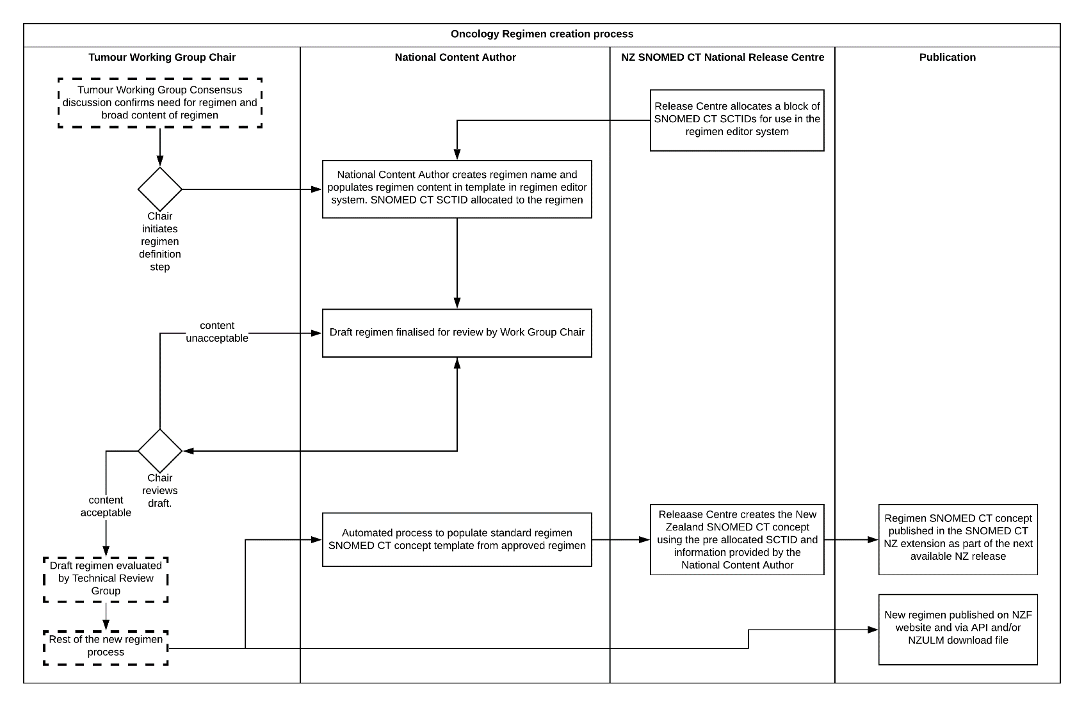

IMPLEMENTATION requirements

Adoption roadmap
Te Aho o Te Kahu will lead national adoption of this standard as an element of the ACT-NOW project under the Cancer Action Plan 2019-2029.

The ACT-NOW project will develop a data and information roadmap that will:
- identify and understand the priority cancer data and information needs of key stakeholders
- understand how to support the implementation of digital technology that can help deliver care in more clinically and cost-effective ways to improve equity
- implement and support an integrated standards-based approach to the collection, retrieval and linkage of high-quality, comparable data at all stages of cancer care, including post-cancer care
- ensure timely distribution of relevant and accurate cancer data and information that addresses identified priorities and addresses our obligations under Te Tiriti o Waitangi
- develop a sustainable approach to ensure rapid access for stakeholders to data and information that enables them to develop actionable insights
- develop a policy and pathway that drives coordination, prioritisation and consistency of approach to cancer information systems to support patient-centred and coordinated care.

The planned steps to implement this standard are as follows:
- publication of approved national standard regimens at the completion of each cancer type working group’s consideration of available cancer unit regimens. The regimens will be published on https://nzf.org.nz/regimens.
- uptake of published regimens by individual cancer units for new patients via manual inclusion into patient care plans created in cancer management software. This supports the capture of data about patient management across the country required by the Cancer Action Plan
- addition of new functionality allowing electronic importation of regimens into cancer management software
- individual cancer units move from manual inclusion of regimens into software care plans to electronic importation of regimens via FHIR API.

Tall Man lettering is an error–prevention strategy to reduce the risk of look-alike and sound-alike medicine name confusion and errors. It uses selective capitalisation to make similar looking medicine names easier to differentiate.
See https://standards.iso.org/ittf/PubliclyAvailableStandards/index.html

