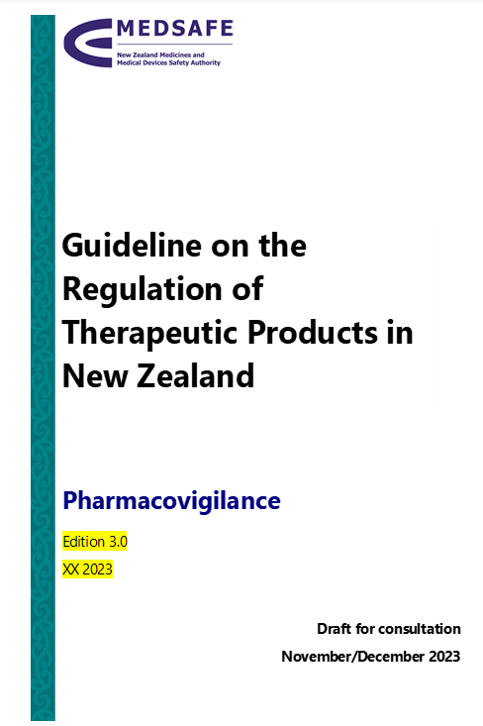 | Throughout the Guideline there have been editorial and formatting improvements.  Removal of section summaries throughout Guideline.  Removal of ‘part 8’ following updates to internal guidance documents.  Edition 3.0 due to major changes to guidance.  Updated publication date (to be finalised).
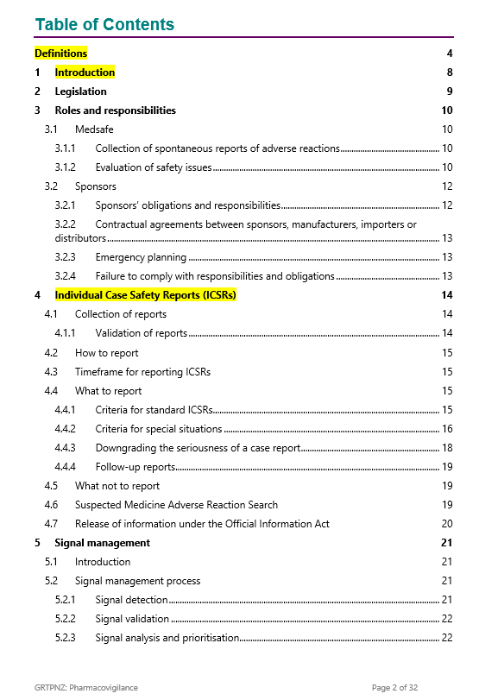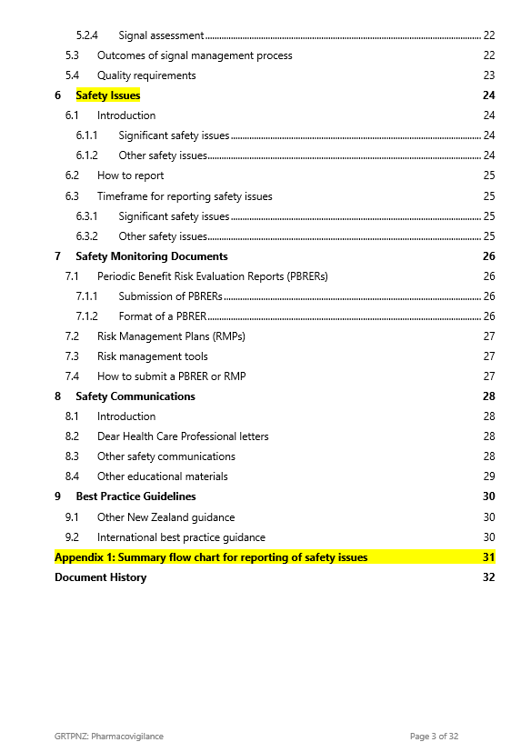 | Table of contents updated following changes throughout the Guideline.  Sub-heading level four (e.g., 1.2.3.4) removed from table of contents.  New appendix added.
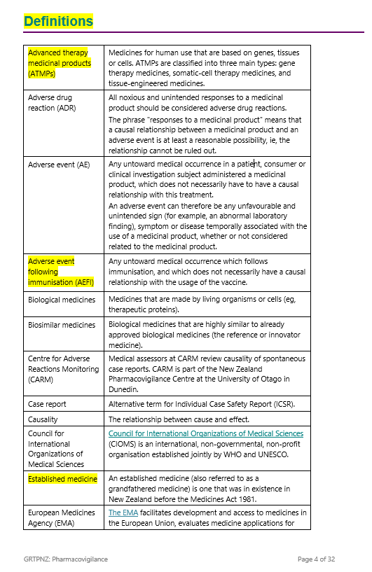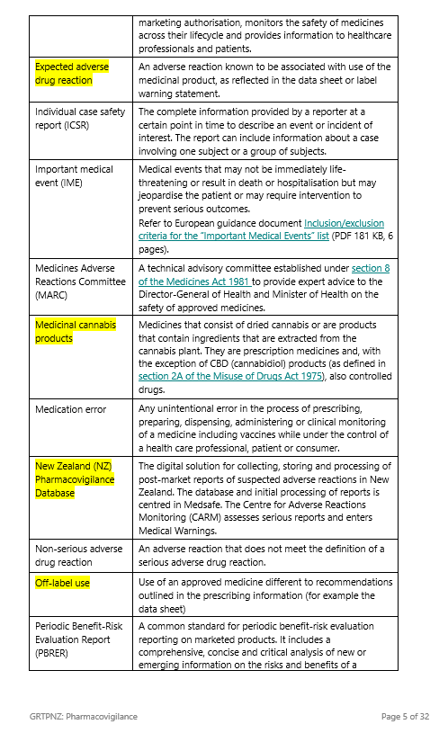 | Glossary section renamed ‘Definitions’ and relocated to start of Guideline.  Any definitions that were previously in the main part of the document have been moved to this section.  New definitions added to align with new information added to the Guideline or where a definition was needed for existing information.  Where appropriate, definitions updated to align with ICH guidelines.  Definitions listed in alphabetical order.
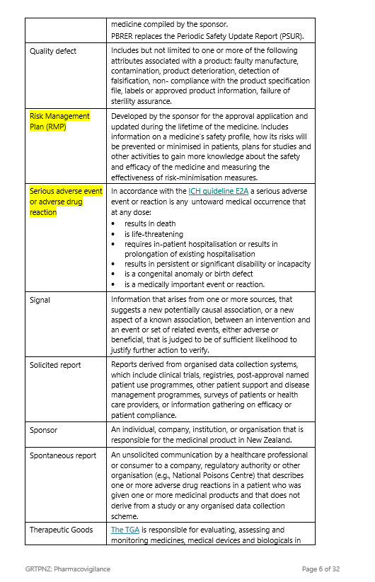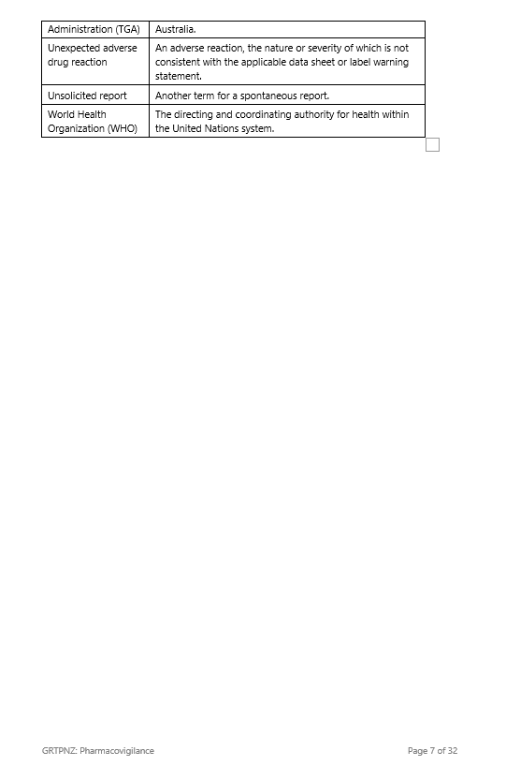
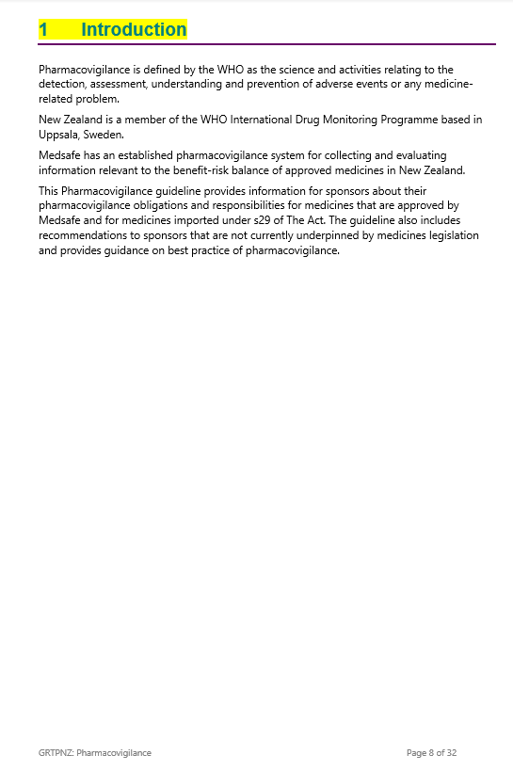  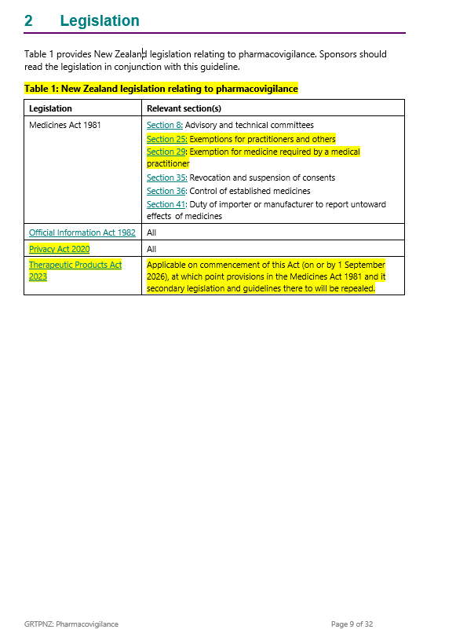 | New section ‘Introduction’.  Content reworded and updated from previous section 2.1.  Relevant legislation reformatted into a table.  Additional links to section 25 and section 29 of the Medicines Act 1981.  Updated to Privacy Act 2020.  Added Therapeutics Products Act 2023.
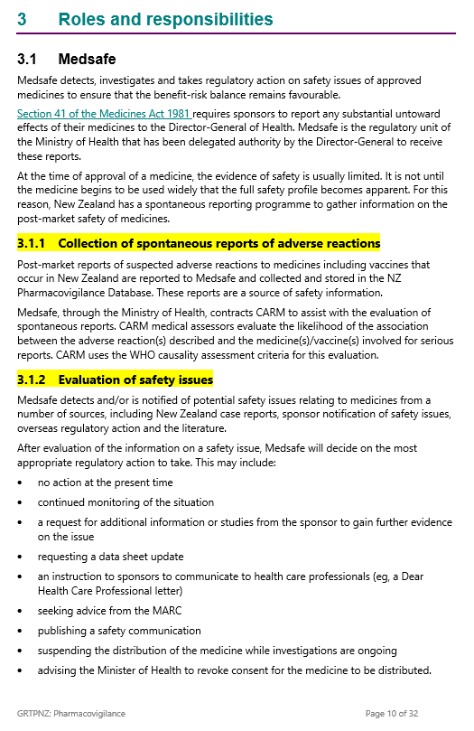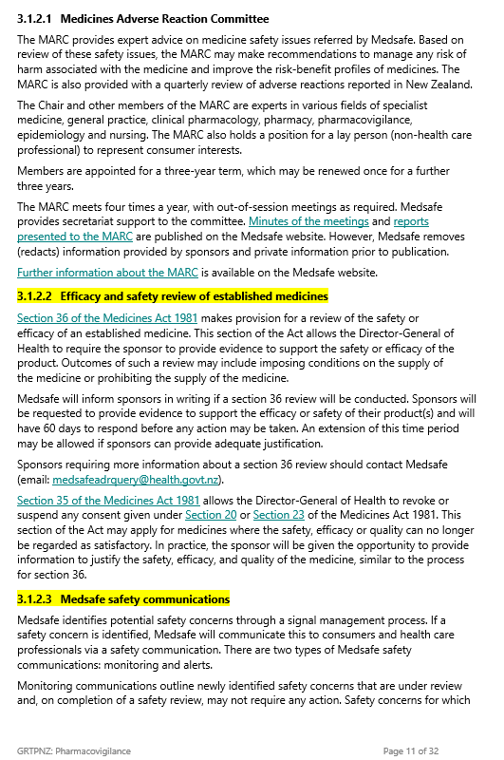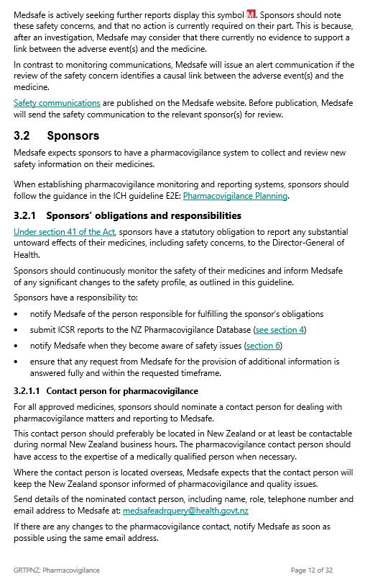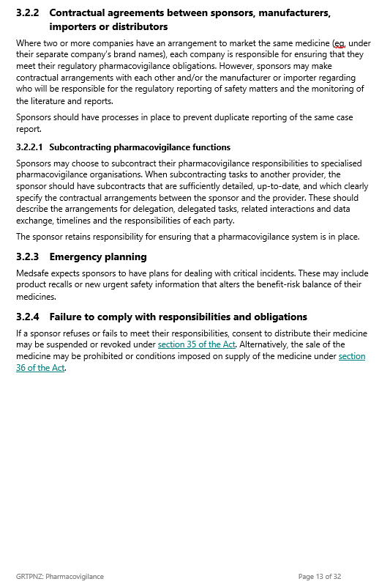 | Reformat and relocation of information relating to roles and responsibilities of Medsafe.  New information about collection of spontaneous reports of adverse reactions following introduction of new NZ Pharmacovigilance Database.  New sub-headings added.  Further information provided about section 35 and section 36 of the Medicines Act 1981.  Information about Medsafe safety communications reworded/relocated into this section.  Minor edits and rewording for paragraphs relating to sponsor’s role and responsibilities.
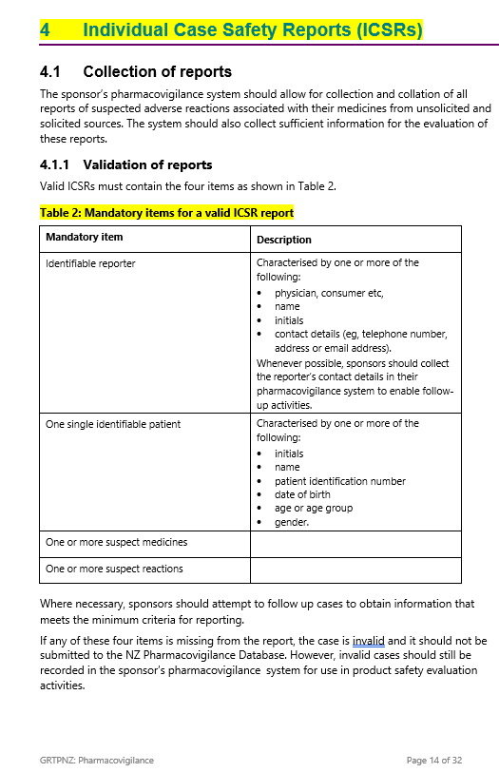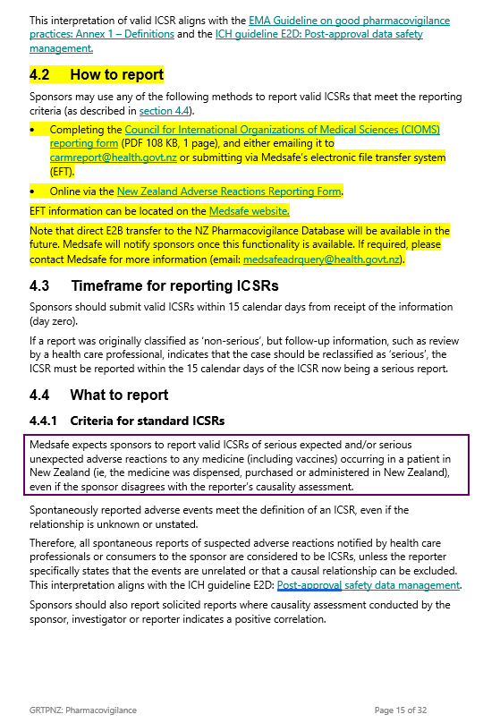 | Section title changed to ‘Individual Case Safety Reports (ICSRs)’.  Rewording and restructure of reporting section for clarity, and to reduce duplication.  Some information moved into table format.  Definitions moved into new ‘Definitions’ section.  New information on how to report following introduction of new New Zealand Pharmacovigilance Database.
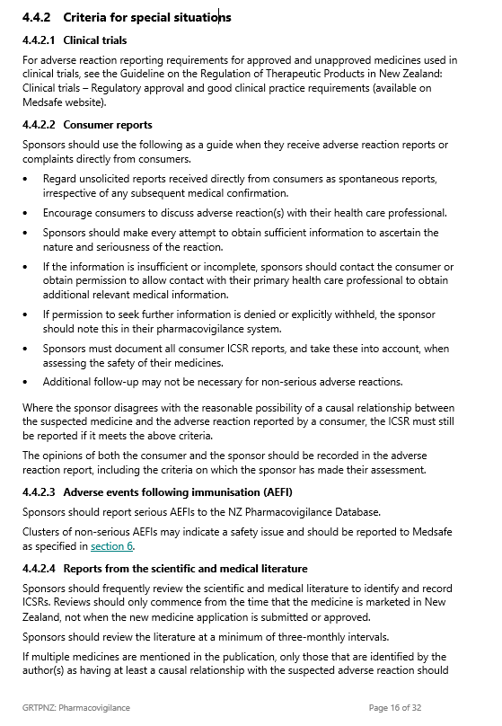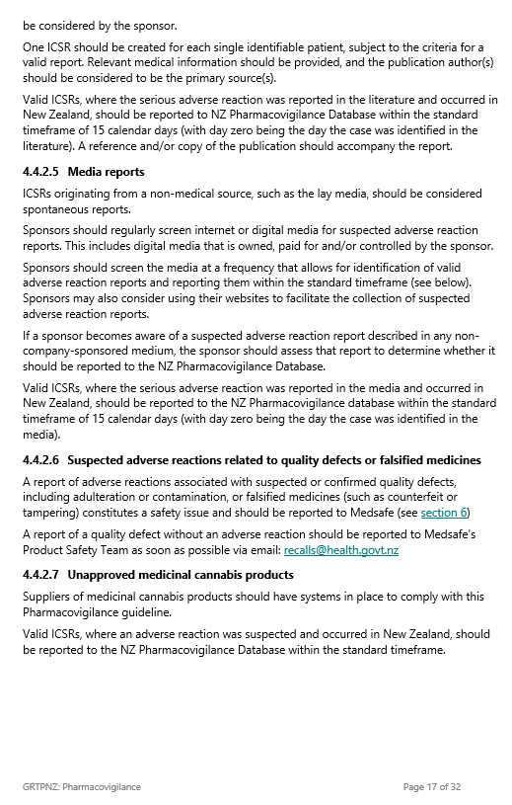
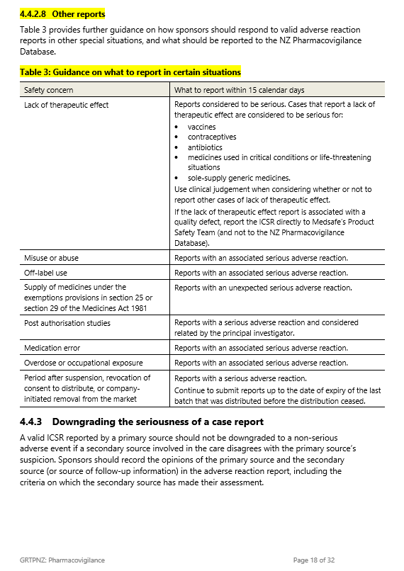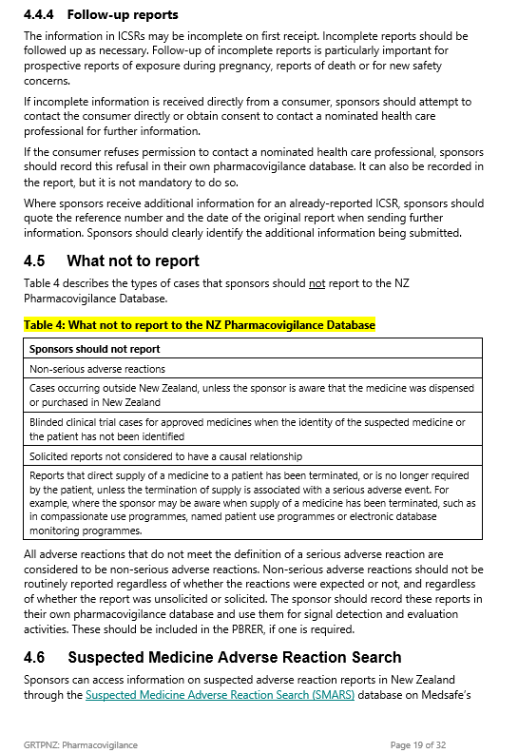
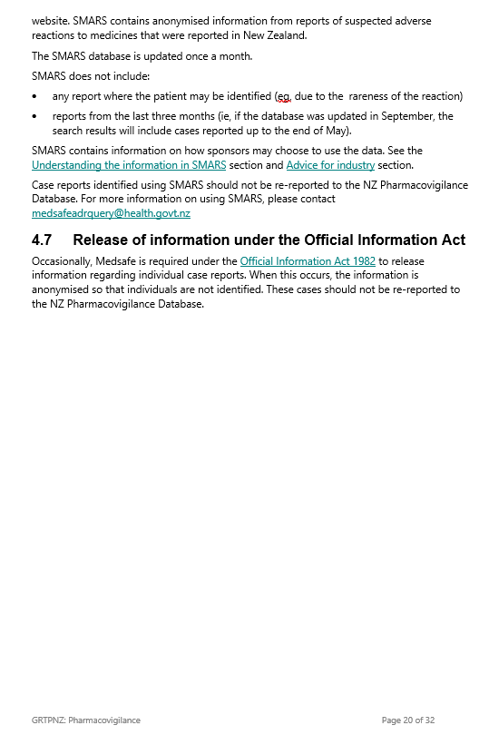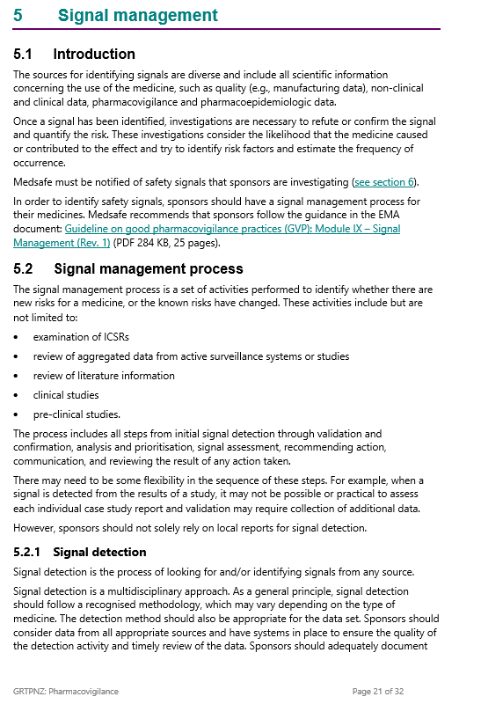 | Minor editing and formatting changes.  Paragraph on Medsafe safety communications relocated to section 2.
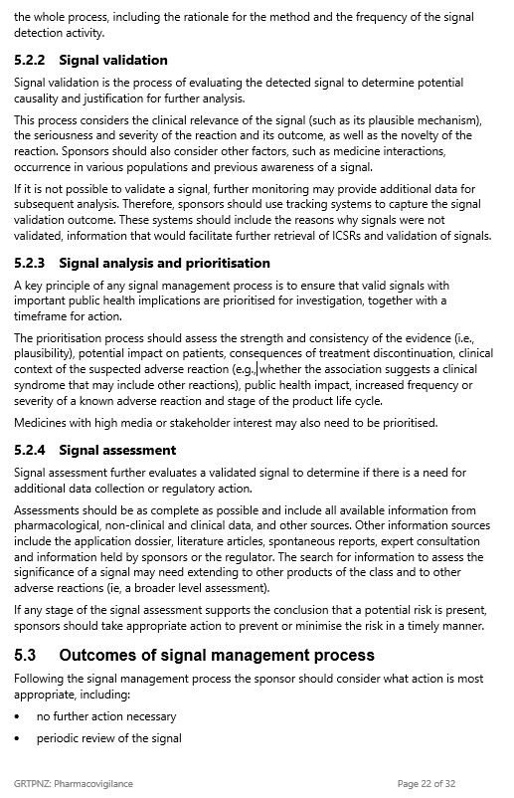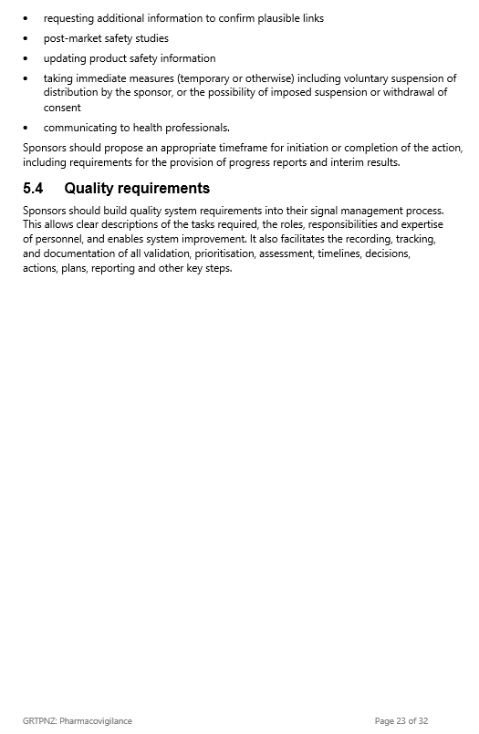
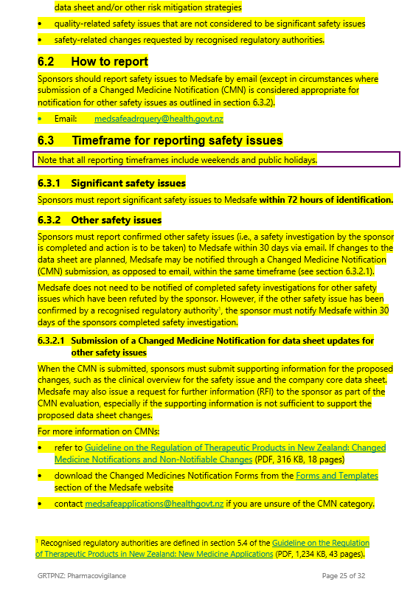  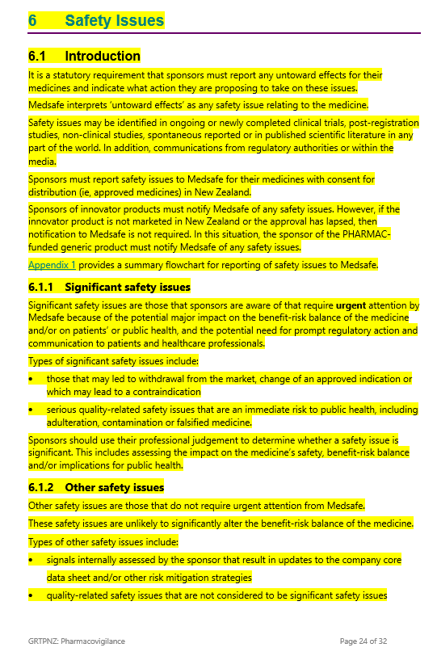 | Renamed section to ‘Safety issues’.  New information on reporting of safety issues for sponsors of PHARMAC-funded generics where New Zealand innovator has left the market or the approval has lapsed.  New definitions for ‘significant safety issue’ and ‘other safety issues’.  New information about ‘other safety issues’ including reporting process and timelines.  Introduction of ‘recognised regulatory authorities’ in relation to other safety issues.  New option for sponsors to notify Medsafe of other safety issues that require data sheet updates through CMN submission (if submitted by required timeframe).
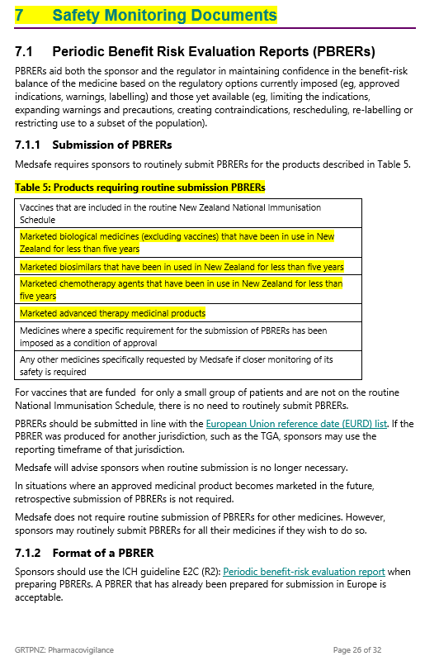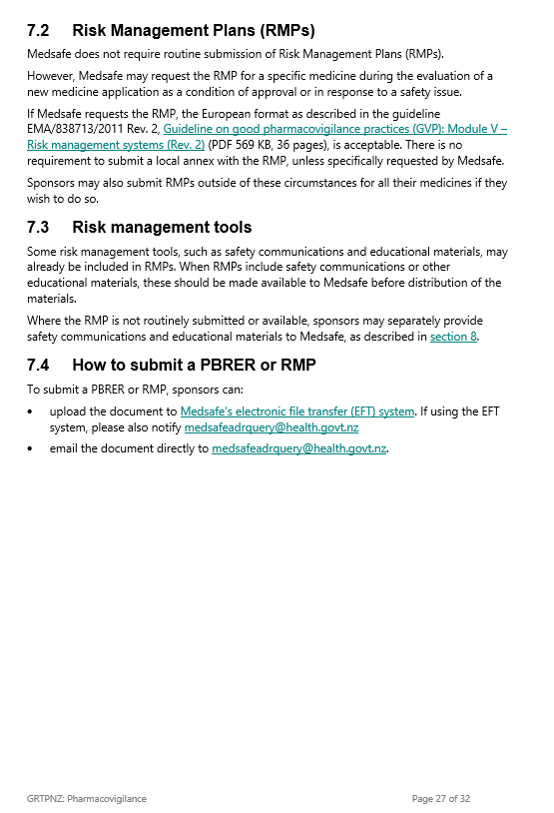 | New information added, in table format, about products requiring routine submission of PBRERs.
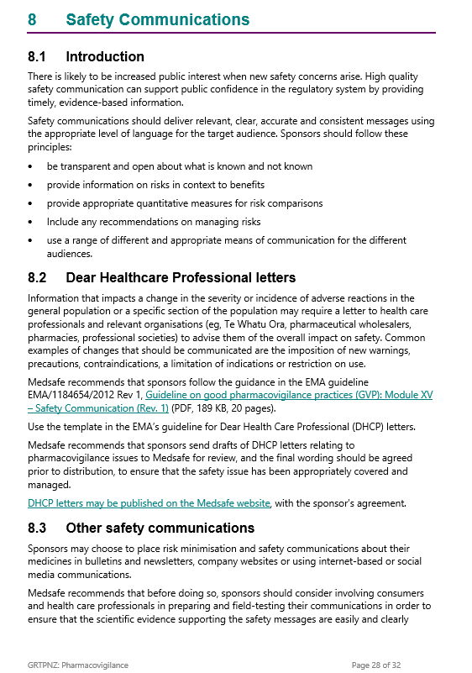 | Minor editing and formatting changes.
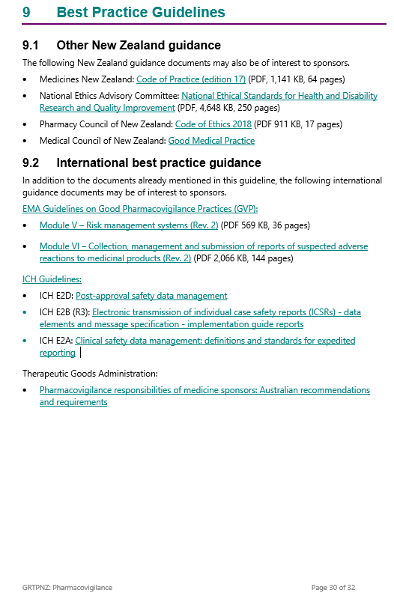 | Minor editing and formatting changes.  Links updated where needed.
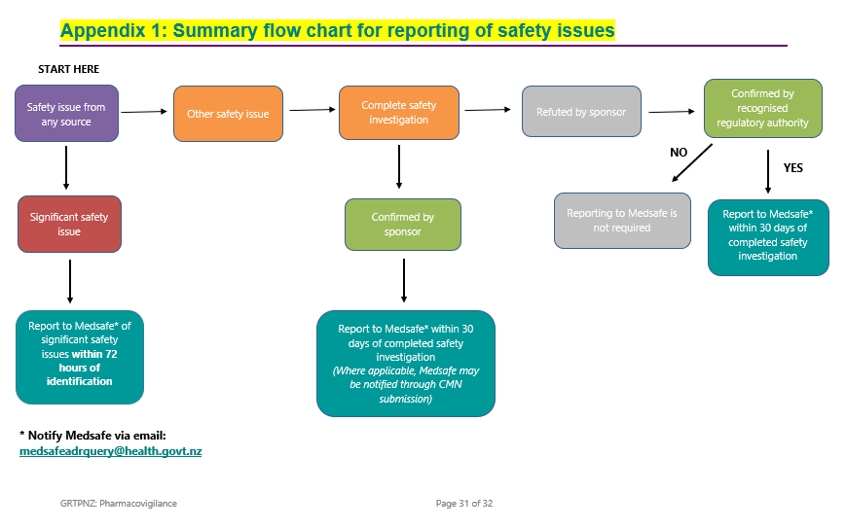 | New appendix to help with changes relating to reporting of safety issues to Medsafe (section 6).
