Appendix 6: Overview of gambling harm from 2019/20 to 2021/22

What we know about gambling in New Zealand

Who gambles
Most New Zealanders gamble at least occasionally.

The Health and Lifestyles Survey (HLS) 2018, showed that 67 percent of respondents (about 2.7 million New Zealanders aged 15 years and older) had participated in some form of gambling in the past 12 months. The HLS is our major source of gambling prevalence data and is provided by Te Hiringa Hauora, Health Promotion Agency (Te Hiringa Hauora).

The overall gambling rate for the previous year for all age groups decreased between 2006/07 and 2012, but since then, it has remained static. The rate for 15- to 24-year-olds declined the most in the period 2006/07–2012, while the rate for people over 65 years old declined the least over the same period. Rates for all ethnicities also showed decreasing participation trends (see Figure 1).

Figure 1: Adults who participated in gambling activities in the previous 12 months, by ethnicity, Results from the Health and Lifestyles Survey
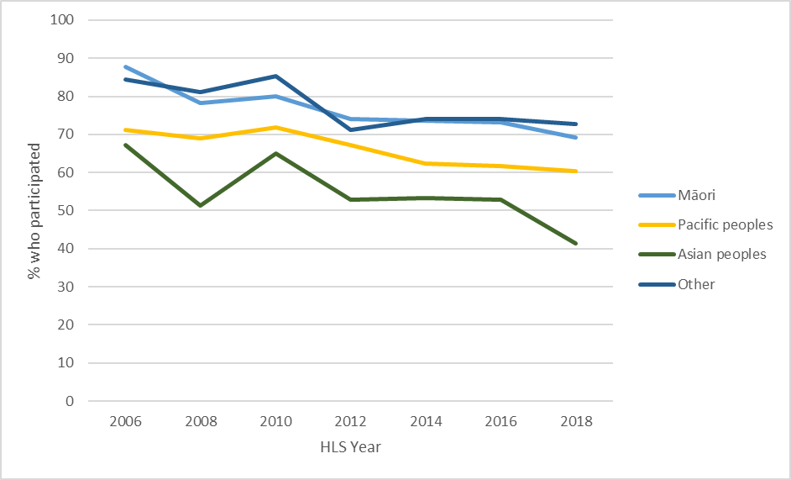

Why people gamble
People gamble for different reasons, and whether gambling is risky, harmful or harmless varies, depending on the individual.

Why do people enjoy gambling? What motivates people to gamble? New Zealand research has identified the following five groups of reasons:
- economic reasons, such as winning or close-to-winning experiences
- personal reasons, such as cognition, motivation for gambling, mental health or mood
- recruitment (or retention) reasons, such as how gambling is normalised, encouraged and promoted through advertising, consumerism or government policy
- environmental reasons, such as the availability and accessibility of gambling activities, features of gaming machines, the gambling entertainment environment and the internet environment
- social reasons, such as the modelling of gambling behaviours and social participation with friends and family members who gamble.

Another way of framing this question is to ask why people transition between risk levels or what causes people to move from being a low-risk to a high-risk gambler, or vice versa. Data from the New Zealand National Gambling Study (NGS) found that reasons for transitioning between risk levels were complex. They included winning money, financial issues, the availability of gambling opportunities, the experience of gambling-related harms, discovering new forms of gambling, social influences and supports, and life events and circumstances.

Other research has found that the transition to risky gambling was most likely to be associated with maintaining or starting several negative health and lifestyle factors over time. This included continuously smoking; maintained poor quality of life and repeatedly experiencing one or more major stressful life events within the previous year; increased depression and reduced community interaction.

Where people gamble
The most popular forms of gambling in 2018 were New Zealand Lotteries Commission products (55 percent), followed by informal gambling (36.9 percent), sports, dog- or horse-race betting provided by TAB NZ (11 percent), gaming machines at a pub or club (11 percent), gaming machines at casinos (4.9 percent), table games at casinos (2.8 percent) and online gambling on overseas websites (2.2 percent).

The Gambling Act 2003 (the Act) defines ‘gambling’ and regulates various forms of gambling activities. It identifies four types of gambling that contribute significantly to gambling harm and are subject to the problem gambling levy:
- non-casino gaming machines (NCGMs or ‘pokies’), operated by clubs, societies and some TAB New Zealand (TAB NZ) venues
- the mixture of table games and gaming machines provided by casinos
- sports and race betting provided by TAB NZ on their mobile app, website, at raceways and through TAB NZ venues (some TAB NZ venues also operate NCGMs)
- a range of lottery products provided by the New Zealand Lotteries Commission (Lotto New Zealand), including: the national lottery, Keno, Instant Kiwi (scratch) tickets and MyLotto online games on their mobile app and website.

Figure 2: Gambling participation, Results from the 2018 Health and Lifestyles Survey
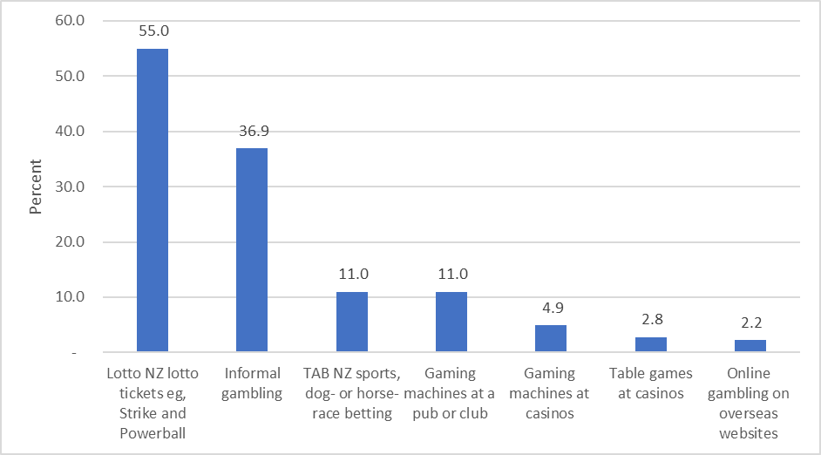

Non-casino gaming machines
As at 30 June 2020, there were 1,074 licensed NCGMs (or ‘pokies’) venues active, operating 14,847 machines.

This reflects a trend of venues and machines decreasing since venues peaked at more than 2,200 in the late 1990s and machines peaked at 25,221 in June 2003. Despite the decline in venue and machine numbers, total NCGM expenditure continues to increase.

Department of Internal Affairs (DIA) reports show that gambling outlets tend to be located in areas with a higher social deprivation rating, for example, over 62 percent of all NCGM venues are located in areas with a high or medium-high social deprivation rating.

Figure 3: Distribution of class-4 NCGM venues by deprivation rating, 2015–2020
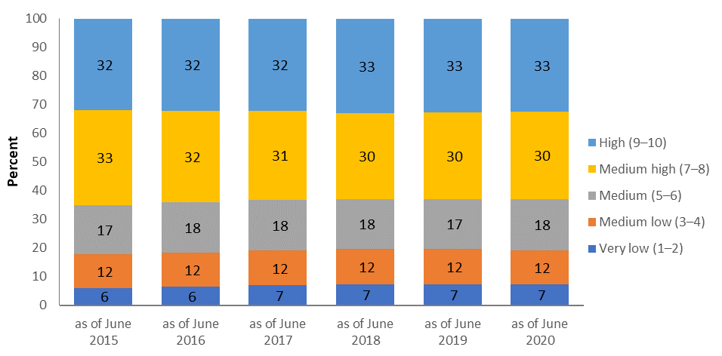

Lottery products
There are over 1,500 lottery outlets and 1,230,000 registered MyLotto account holders.

Lotto New Zealand’s 2019/20 annual report states that there were 1,230,000 registered MyLotto account holders compared with 845,000 in the previous year. The increase in registered MyLotto players was attributed to the closure of the retail network during COVID-19 alert level 4 restrictions, so that lotto purchases were only available online. According to the HLS 2018, the single most common form of online gambling was purchasing tickets via the MyLotto app (9 percent).

Sports betting
In the 12 months to 28 February 2021, there were 205,000 active TAB NZ customers. According to the HLS 2018, about 4 percent of New Zealanders placed a bet with TAB NZ online in the previous 12 months.

As at 28 February 2021, there were 560 retail TAB outlets. Of these, 44 hosted gaming machines in the previous 12 months. The monthly trading reports provide the number of customers that bet in a given month.

Casinos
There are six casinos in New Zealand: one each in Auckland, Hamilton, Christchurch, and Dunedin, and two in Queenstown. 4.9 percent of New Zealanders had played gaming machines at casinos and 2.8 percent had played table games at casinos in the previous 12 months according to the 2018 HLS.

The casinos operate a total of just over 3,056 gaming machines, 239 table games and 240 fully automated gambling machines. The Christchurch Casino was the first casino to open in this country, in 1994. The Hamilton casino was the last, in 2002. The Act prohibits any more casinos opening in Aotearoa New Zealand.

COVID-19’s impact on casino gambling
All casinos closed in March 2020 following the enforcement of COVID-19 alert levels 3 and 4 restrictions. Most reopened on 14 May 2020 following the Government’s decision to move to the country to alert level 2. SkyCity Wharf Casino in Queenstown was still closed at the time of drafting this document. Ongoing border restrictions have had a noticeable impact on the casino industry, in particular as international visitors generally form a large proportion of patrons.

Online gambling
Over 520,000 (13 percent) New Zealand adults (aged 15 years and over) took part in online gambling in 2018. Most online gambling occurred with domestic providers (Lotto New Zealand and TAB NZ), while only 2 percent of New Zealanders reported gambling on an overseas website in the last 12 months.

There are concerns about the growing opportunities for online gambling, in particular, those offered by overseas-based gambling operators, and their potential to increase harmful gambling behaviour. While it is illegal for offshore online gambling operators to advertise in New Zealand, it is not illegal for New Zealanders’ to gamble on offshore sites.

Observation of patterns of online gambling in overseas jurisdictions has led to stakeholders expressing concerns that New Zealanders’ participation in online gambling may dramatically increase, and with it their potential risks of harm. Increases in online gambling overseas are attributed to the growth in online providers and products facilitated by rapid changes in technology, increasing ease of access to the internet, and the widespread prevalence of digital devices. These trends are also underway in New Zealand.

Previous research into New Zealanders’ overseas gambling patterns has shown very low participation rates and low levels of reported expenditure. According to results from the 2018 HLS, the proportion of New Zealanders gambling on overseas websites has remained stable at around 2 percent since 2010 when overseas website gambling was first asked about. However, those who did gamble on overseas websites were 80 percent more likely to be at-risk gamblers compared with other gamblers. This rate of participation is comparable with figures from the economics data analysis company Sense Partners (2019) who estimated there to be around 70,000 offshore online gamblers, equating to around 1.7 percent of the working-age population and 1.4 percent of the total population. However, the availability of smart, internet-based technologies and devices (and gaming convergence as discussed below) has steadily grown and with it the risk of increased gambling harm.

As shown above, an increasing number of people in New Zealand purchased Lotto New Zealand products or placed bets on TAB NZ products online in 2018. According to the 2018 HLS, over 520,000 (13 percent) New Zealand adults (aged 15 years and over) took part in online gambling in 2018. The single most common form of online gambling was purchasing tickets via the MyLotto app (9 percent). This is followed by betting online with TAB NZ (4 percent). According to Lotto New Zealand’s annual report for 2019/20, digital channel sales for the year totalled $430.6 million. This was 59.3 percent higher than Lotto New Zealand’s target of $270.2 million.

SkyCity Entertainment Group, in partnership with international iGaming company Gaming Innovation Group Inc, launched SkyCity Online Casino in August 2019. The online casino is operated out of Malta as it is currently illegal for New Zealand-based providers to provide online casino gambling options. As of August 2020, the online casino reported over 35,000 registered customers.

Many online gambling websites promote their services with free-to-play games that appear to be gambling but do not involve ‘real money’. For example, SkyCity launched a free-to-play online gaming site in 2015, with virtual gaming machines (simulated NCGMs) and table games. Free-to-play sites avoid the Act’s prohibition on advertising as, by definition, no gambling is taking place on the site advertised.

DIA is currently conducting a review into online gambling in New Zealand. A discussion document was released in July 2019 seeking New Zealanders’ views on a future regulatory framework for online gambling. The review is ongoing at the time of drafting this document.

COVID-19’s impact on online gambling
Online gambling increased during the COVID-19 lockdown period, and some people gambled a lot more in that time than pre-lockdown.

Online gambling increased over the COVID-19 lockdown period, from about $4.1 million a week at the start of 2020 to $6.25 million a week during the levels 3 and 4 lockdown. Compared with the same period in the previous year, spending on online gambling during lockdown was up 51 percent. Online gambling has been increasing over time and was 8 percent higher in the first quarter of 2020 (before the COVID-19 lockdown) than in the same quarter of the previous year. This suggests that the lockdown boosted online gambling by about 43 percent. Of those who gamble, most reported gambling less since the lockdown ended.

During the alert level 4 lockdown, Te Hiringa Hauora (formerly the Health Promotion Agency) conducted an online survey to understand the lockdown’s impact on health risk behaviours, including gambling. Thirty-nine percent of respondents reported that they had gambled since the first lockdown. Of those who gambled, most reported gambling less during lockdown (50 percent) or the same (41 percent) as they usually would, and 9 percent reported increasing their gambling. When asked about their online gambling, most reported gambling online less (24 percent) or the same (33 percent) as usual. In all, 12 percent reported gambling more than usual, and 8 percent reported that they gambled online for the first time during lockdown. Of those who gambled online during lockdown (77 percent of respondents), the majority (65 percent) reported using MyLotto.

In a follow-up survey, gambling levels were reported to be less than pre-lockdown across all gambling types, including online gambling. While fewer respondents report gambling online compared with before lockdown, use of some online gambling sites had increased among those who do gamble online. For example, use of the SkyCity online casino increased among online gamblers (from 8 percent to 17 percent).

These findings are supported by SkyCity Entertainment Group’s annual report for the year ended 30 June 2020, which indicates that their online casino business increased significantly when New Zealand went into lockdown, with around 15,000 new customer registrations between 23 March and 14 May 2020.

SkyCity noted a slight reduction in online gaming revenue following the reopening of its physical casino venues after New Zealand moved to alert level 2 on 13 May 2020. They again saw an increase in online gambling activity when Auckland SkyCity was required to close in August 2020 because the Auckland region moved to alert level 3 once more. By 31 August 2020, there were over 35,000 customer registrations, with a reported 2019/20 online revenue of $4.5 million.

Gambling in video games or gaming convergence
‘Gaming convergence’ is the merging of gambling and gaming elements in a single product. The two main examples are where:
- gambling takes on the visual and aural cues associated with gaming; for example, in New Zealand, virtual reality-enabled Instant Kiwi tickets (such forms of gambling are also an example of continuous gambling, which research shows poses an increased risk of harm)
- video games include elements of what appears to be gambling (but does not currently meet the definition of gambling under the Act); for example, opening loot boxes and spinning wheels to unlock ‘power ups’.

Gaming convergence, when coupled with associated increased levels of advertising and internet-based payment systems that make it easier to spend money on gambling products, represents the emergence of a new level of exposure to high-risk gambling products in New Zealand and the associated probability of related gambling harm. However, while these games look and feel like gambling, they do not meet the current definition under the Act (because there is no opportunity to stake, win or lose real money). This is of concern because there is evidence that video gaming problems may be associated with problematic gambling behaviour.

Spending on gambling
DIA data shows that total gambling expenditure (player losses) on the four main forms of gambling is continuing a trend of increasing each year, with 2019/20 being a notable exception (likely because of the restrictions resulting from the COVID-19 pandemic lockdowns).

In particular, DIA data showed the following.
- Total gambling expenditure in 2019/20 was $2,251 million for NCGMs, Lotto New Zealand, TAB NZ and casinos combined. This is lower than any of the three previous years, likely as a result of the COVID-19 lockdown, which required public venues to close for seven to eight weeks.
- Expenditure on NCGMs has continued to increase annually from a low of $806 million in 2013/14, to a high of $924 million in 2018/19. However, for 2019/20, the total was $802 million. Once again, this drop can be primarily attributed to the significant loss of gaming machine profits (GMP) as a result of the COVID-19 lockdowns. Despite this decrease, in the October to December 2020 quarter, GMP was the highest quarterly figure since records began in 2007.
- Expenditure on Lotto New Zealand products in 2019/20 increased significantly to $631 million; over $100 million more than the 2018/19 year, making it Lotto New Zealand’s largest turnover ever as more New Zealanders moved to online gambling during lockdown. Note that annual expenditure on Lotto products is volatile, depending on the number and size of Powerball jackpots.
- In contrast, annual expenditure on TAB NZ products remained fairly steady, around the $300 to $350 million range. For 2019/20, the total was $315 million, which represented about a 5 percent decrease on the previous year.
- Annual expenditure on casinos in 2019/20 was $504 million, a significant decrease compared with previous years. Again, a key contributing factor to this was the COVID-19 lockdown period, which forced venues to close and later impose social distancing restrictions, as well as continuing restrictions on international travel.

Figure 4 below shows the average per-capita gambling expenditure for each of the four main forms of gambling. Note that actual expenditure levels are higher than the figure suggests, since the levels in the figure apply to all people in New Zealand, including the one-third of the population who report that they do not gamble at all.

Gambling expenditure trends show an increase in real terms across all four gambling sectors. Adjusting for inflation by type of gambling shows that spending levels have remained relatively unchanged in recent years. As noted above, the 2019/20 year was an exception. COVID-19 meant a decrease in gambling spend, except for Lotto which increased.

Figure 4: Inflation-adjusted expenditure (2020) per capita (adults aged over 18 years), by type of gambling, 2010/11–2019/20
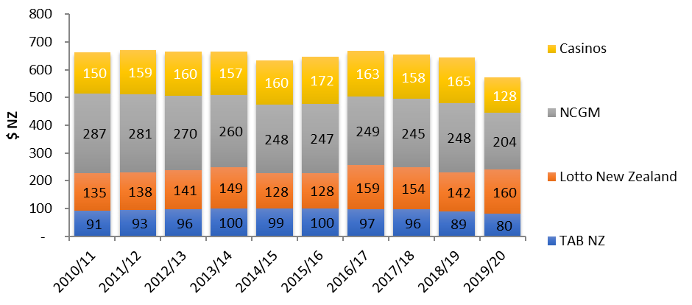

The nature of gambling harm
The Act defines harm as:
harm or distress of any kind arising from, or caused or exacerbated by, a person’s gambling; and
- includes personal, social, or economic harm suffered –
- by the person; or
- by the person’s spouse, civil union partner, de facto partner, family, whānau, or wider community; or
- in the workplace; or
- by society at large.

Harm may include damage to relationships, emotional and psychological distress, disruptions to work or study, loss of income, the financial impacts of gambling and potentially fraud and related crimes, which can also impact negatively on the gambler’s family, whānau and community. It may also cause financial stress and anxiety and contribute to child neglect and family violence.

Measuring harm
We can measure gambling harm at both the population and the individual level.

The Problem Gambling Severity Index
The HLS and other population surveys utilise the internationally validated Problem Gambling Severity Index (PGSI). The PGSI differentiates between different types of harm and frequency of harm occurring, as reported by survey respondents. The PGSI is commonly used, including by clinical intervention services funded by the Ministry of Health (Ministry), to screen and categorise three levels of harm: severe or high risk (problem gambling), moderate risk and low risk.

While the proportion of the population of Aotearoa New Zealand who are at risk of gambling harm as measured by the PGSI is currently at the lowest level since the early 1990s, the level of harm in the overall population has remained relatively stable since 2012 (at about 5 percent).

However, while gambling harm rates have not significantly changed, the adult population has grown. This means that the number of people experiencing gambling-related harm has increased. This plateau effect has also been observed overseas.

Estimates as measured by the PGSI suggest that, in Aotearoa New Zealand in 2018, there were 76,000 people aged 15 years or older who were at either moderate risk or high risk of harm from gambling (‘problem gamblers’). A further 142,000 were at low risk but would experience gambling-related harm during their lifetimes. About 268,000 adults reported second-hand gambling harm in their wider families or households.

The burden-of-harm impact on health-related quality of life
Another measure of gambling harm is known as the burden-of-harm impact on health-related quality of life. Research shows that the total burden of harms that gamblers experience, in terms of the decrease to health-related quality of life years, is greater than the harm they experience from common health conditions, such as diabetes and arthritis, and approaches the levels seen with anxiety and depressive disorders. Importantly, the harm attributable to gamblers who participate in low-risk gambling is very significant, with one study finding nearly 50 percent of all gambling harm being experienced by these people. This finding, known as the ‘prevention paradox’, is widespread across health research in many areas and jurisdiction and has been found in other gambling research. This is because many more people experience low levels of harm or burden of disease than people who experience high levels.

Research shows that one in five New Zealand adults (22 percent) is affected at some time in their lives by their own gambling or others’ gambling.

Forms of gambling associated with gambling harm
Some features and/or modes of gambling are particularly associated with harm. Evidence shows that harm is far more likely to be associated with continuous forms of gambling (those in which a gambler can immediately ‘reinvest’ their winnings in further gambling) than other modes of gambling.

The main forms of gambling (land-based and online) that have this ‘continuous’ nature are gaming machines (in or out of a casino), casino table games, ‘scratchies’ (Instant Kiwi) and sports/race betting. Modes considered to be non-continuous include traditional lottery draws and raffles, as there is a delay of many hours or days between placing a stake or buying a ticket and receiving the result of a win or loss.

Non-casino gaming machines
Most of the money spent on gambling in New Zealand comes from the relatively limited number of people who play non-casino or casino gaming machines or both. Most people accessing gambling-harm intervention services cite pub or club pokies as the primary problem gambling mode.

The most harmful form of gambling in New Zealand is NCGMs at pubs/clubs (defined in the Act as class 4 gambling). This has been the case for many years. The 2014 NGS found that at-risk and problem gamblers accounted for over half of total (estimated) electronic gaming machine (EGM) expenditure in 2015 (moderate-risk and problem gamblers 28 percent; low-risk gamblers 24 percent). Similarly, the 2018 HLS found that one-third (33 percent) of people who played NCGMs in pubs or clubs at least once a month experienced at least some level of gambling harm.

Who is bearing the burden of gambling harm?
While many New Zealanders who gamble do so without experiencing harm, a significant minority either experience harm from their own gambling or their gambling negatively impacts the lives of others. Harm may include damage to relationships, emotional and psychological distress, disruptions to work or study, loss of income, the financial impacts of gambling (including stress and anxiety) and potentially fraud and related crimes, which can also impact negatively on the gambler’s family, whānau and community. Gambling may also contribute to child neglect and family violence.

Research shows that Māori and Pacific peoples, some Asian communities and young people / rangatahi disproportionately experience gambling harm.

The HLS shows that Māori were four times more likely to be moderate risk and problem gamblers compared with non-Māori. In the Māori adult population, approximately 5.9 percent were moderate-risk / problem gamblers, and 4.5 percent were low-risk gamblers.

The HLS shows that Pacific peoples were about 1.6 times more likely to be moderate-risk and problem gamblers compared with non-Pacific peoples. Approximately 3.5 percent of Pacific adults were moderate-risk / problem gamblers, and 3.0 percent were low-risk gamblers.
Māori and Pacific peoples are also more likely to have other risk factors for gambling harm, such as having low incomes and living in low socioeconomic communities where some forms of gambling, particularly NCGMs are more accessible. The disproportionate burden of harm from gambling that is being shouldered by Maori and Pacific peoples is not new and has been identified at least since the 2011/12 New Zealand Health Survey.

Past HLS survey results show the proportion of Asians who gamble is relatively low when compared with Māori, Pacific peoples and European/Other; however, those who do gamble are more likely to experience harm compared with European/Other. Approximately 1.1 percent of Asian adults were moderate-risk / problem gamblers, and 3.8 percent were low-risk gamblers. The HLS also indicate that awareness of what to do to help a friend or family member who gambles too much is lower for Asian peoples.

Living in areas of higher deprivation is associated with greater risk of gambling harm. The 2018 HLS found that women living in areas with a high New Zealand socioeconomic deprivation (NZDep) index score were two times (2.18) more likely than women in areas of low deprivation to experience gambling-related arguments or money problems related to gambling. After adjusting for deprivation level, Māori were over two-and-a-half times more likely to report either gambling-related arguments or money problems related to gambling compared with non-Māori.

The 2018 HLS identified that young people aged 15–24 years made up approximately 27 percent (21,000 people) of the total proportion of moderate-risk and harmful gamblers (1.9 percent of all adults or 76,000 people). While there was a decrease in youth gambling from 2016 to 2018, this decrease follows more than a decade of increasing or static prevalence rates, and it is not yet clear if this represents a genuine change in the direction of the trend.

Research has identified specific harms from some kinds of gambling to children and young people. Preliminary findings from research examining video games and Pacific youth gambling suggest that there are some parallels between problem gaming and problem gambling behaviour. This research found that 28 percent of Pacific survey respondents spend more than $20 per month on loot boxes, and Pacific young people in the study drew parallels between problem gaming and problem gambling.

This aligns with a Norwegian longitudinal study, which found that people who bet on gaming enhancements, such as skins, when they were children and continued gambling online when they became adults had higher rates of at-risk and problem gambling as adults than people who did not bet on gaming enhancements when they were children.

There are growing concerns about the accessibility of online gambling and gaming convergence and the impacts of these on the wellbeing of children and young people / rangatahi. People interviewed for the Ministry-commissioned 2021 needs assessment highlighted increasing numbers of parents asking for support for young people who were ‘addicted’ to gaming.

There is also some anecdotal concern that increasing unregulated online gambling may be particularly harmful for people with disabilities. Almost one in four New Zealanders identify as disabled, and these proportions are larger in the groups that we know are vulnerable to harm from gambling, that is, Māori, Pacific peoples and people with low incomes. We have limited information about gambling among the disabled community in New Zealand, but American research has found that one-quarter of recipients of disability benefits were experiencing harm from gambling. Additionally, recent small-scale Australian research found people with intellectual disabilities are engaging with gambling in the same ways as the general public.

Women, who are commonly the primary caregivers within their family or whānau, are also particularly vulnerable to the economic strain caused by problem gambling. Recent research has shown that sociocultural positioning of women as the primary caregivers for families contributes to gambling harm by placing unrealistic expectations on the women while simultaneously constraining their ability to prioritise their own wellbeing and access rest, relaxation and support. Gambling venues in local communities appear to offer women respite, distraction, comfort, time out and/or connection, while placing them at increased risk of experiencing problems and harm.

A report from the Pacific Island Families Study found that risk factors for gambling among mothers studied included alcohol consumption, being a victim of verbal abuse and increased deprivation levels.

Problem gambling and other health problems
Harmful gambling typically presents with other health issues and has been consistently associated with a range of co-existing health issues, such as higher levels of smoking, hazardous alcohol consumption and other drug use, as well as higher levels of depression and poorer self-rated health. Comorbidity is an indication that a person may require holistic health services.

Of clients screened by Ministry-funded health services for co-existing problematic alcohol or drug use in 2019/20, a total of 21 percent reported feeling the need to cut down their use of prescription or other drugs and 34 percent reported having risky levels of alcohol use.

Broader harms
Gambling harm can be experienced not only by people who gamble but also by their friends, families, whānau and communities. Australian research suggests that 5–10 other people are adversely affected by a gambler who has severe problematic gambling behaviour.

In New Zealand, we know that harmful gambling behaviour is strongly correlated with family, whānau or partner violence, with half of problem gamblers reporting having experienced family or whānau violence. There is also evidence that children and young adults are exposed to considerable gambling messaging, for example, through advertising, which can normalise harmful gambling behaviours.

It is also useful to consider the effect of the large amount of expenditure that is currently being put into gambling. New Zealanders are currently losing around $2.4 billion per annum on gambling, with almost $1 billion of that on EGMs alone. In all, 40 percent of players’ losses on NCGMs must be returned to the community in the form of grants. Recent research in Aotearoa New Zealand estimated that, if the current levels of household expenditure on EGMs were switched to retail spending, this could create an additional 1,127 full-time equivalent jobs for 1,724 workers, worth approximately $50 million in wages and salaries. The tax impacts on this would be nearly $60 million in increased GST collected and $7 million in income tax on workers. This research assumed that all spending would be switched to retail and none to other forms of gambling, but if we assumed that half were switched to retail and half to other forms of gambling, it is clear that spending on NCGMs is costly for communities as well as individuals.

It is also clear that spending on gambling, especially NCGMs, is not spread evenly across our communities. This is at least partly due to access. More than 60 percent of NCGMs venues (the source of the highest risk of harmful gambling activity) are located in the most socioeconomically deprived areas (that is, the poorest areas of the country). People in these areas spend up to three times as much on NCGMs as people in the least deprived area. While it is possible that people may gamble outside their neighbourhoods, there are significant associations between gambling behaviour and neighbourhood access to gambling venues. In particular, problem gambling has been found to be significantly associated with living closer to a gambling venue.

Service delivery in the 2019/20 to 2021/22 period
This section provides an overview of preventing and minimising gambling harm (PMGH) service delivery during the 2019/20 to 2021/22 period.

Service access rates
Every year, people seek help from services funded by the Ministry for harms due to their own or someone else’s gambling. In the 2019/20 year, over 5,500 people received treatment from Ministry-funded services for harms due to their own gambling. This is a small proportion of the 43,000 to 124,000 people that the 2018 HLS estimated were experiencing moderate to significant harms from their own gambling. In addition, between 205,000 and 343,000 New Zealand adults experienced at least one form of household-level gambling harm in the previous 12 months. In the 2019/20 year, around 3,952 families or whānau and others received treatment from Ministry-funded services for issues related to someone else’s gambling.

As Figure 5 below shows, there has been a general decrease in people accessing Ministry-funded services. This decrease results from a range of factors and needs to be addressed promptly. The Ministry’s suggestions for ways to address this issue are discussed in the draft Strategy to Prevent and Minimise Gambling Harm 2022/23 to 2024/25 (the strategy).

This discussion in this section focuses on people with moderate- to high-risk behaviours. The Ministry also funds prevention and early intervention services, which are discussed later in this appendix.

Figure 5: Clients accessing Ministry-funded services (Excluding Brief Interventions)
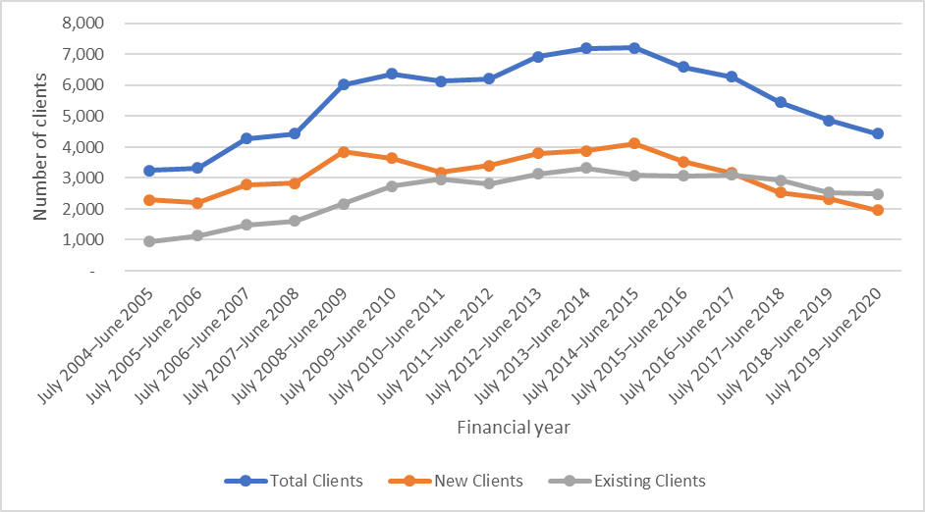

Developments in the gambling-harm services environment
The COVID-19 pandemic and resulting public health restrictions, such as social distancing requirements, had a significant impact on the gambling-harm services environment. Face-to-face service provision decreased dramatically, leading to a rapid increase in virtual service provision (over the telephone or through online meetings). While this shift highlighted the adaptability of health service providers, it also exacerbated the negative impacts of the restrictions on people who do not have ready access to digital software. In addition to COVID-19, there were a number of developments in the gambling-harm services environment over the 2019/20 to 2021/22 period.
- Funding for the national Multi-venue Exclusion (MVE) Administration Service continued, and a national framework and standardised process were developed. MVE is now available across the country. An electronic gambling exclusions database was also procured, and the collection of exclusion data was trialled.
- Two new service pilots were introduced in the Waikato region: a PMGH service for Māori and one for Pacific peoples. Both services are based in Hamilton and are within organisations that are existing Whānau Ora providers (Te Kōhao Health and K’aute Pasifika Trust respectively).
- A gambling harm lived experience advisory group was established to inform the Ministry’s gambling harm work programme.
- As of 10 May 2021, just on 40 percent of local authorities had sinking-lid policies in place for NCGMs, and a further 48 percent had caps on the number of venues and/or machines in their area.
- As of 10 May 2021, a total of 27 of the 67 territorial authorities had reviewed their class 4 and TAB venue policies since 1 July 2019.

Public health provision in the 2019/20 to 2021/22 period
Public health service providers continued to encourage the adoption of healthy gambling policies, and many providers led their community’s participation in territorial local authority class 4 reviews. They also worked alongside other agencies and community groups to develop community action initiatives that aim to increase community resiliency against gambling harm and continued to engage with their local gambling venues to support gambling harm minimisation practices and promote their PMGH services.

National and regional health service providers delivered a wide range of health promotion activities. These included raising awareness of the signs of gambling harm by delivering numerous presentations and workshops to organisations and groups, attending hundreds of community events and through online media communications, social media and resources.

Te Hiringa Hauora’s health promotion programme focuses on encouraging positive behaviour change among at-risk gamblers and raising awareness about the signs of harmful gambling and risky gambling behaviours. Developments led by Te Hiringa Hauora have included an increased focus on equity through a number of initiatives such as the rebranding of the national gambling campaign Choice Not Chance to Safer Gambling Aotearoa; development of South Auckland pilot campaigns and a new national campaign primarily focusing on Māori and Pacific communities. A review of the Gamble Host Responsibility project also led to a number of improvements, including the development of an online version of the host responsibility training and ethnic-specific resources (scheduled for completion this financial year).

During 2020, many planned promotional activities, including some Gambling Harm Awareness Week (GHAW) activities, did not proceed due to the COVID-19 restrictions. Notable successes have included a relationship established with Kiwibank, resulting in gambling harm screening and referral training delivered to some of their debt recovery units; the development of a TXT2X (text to exclude) toolkit to promote the use of MVEs; and many community groups and venues supporting the Pause the Pokies campaign during GHAW.

Service access
Analysis of Ministry gambling service administrative data for 2018/19 and 2019/20 shows that the number of gamblers seeking treatment continues to decline in Aotearoa New Zealand, despite the increase in real numbers of people experiencing gambling harm. In the 2019/20 year, 5,550 ‘Gambler’ clients and 3,952 ‘Family / Affected Other’ clients received gambling harm treatment services from a Ministry-funded provider. This decline is largely attributable to fewer new clients presenting to services, a factor almost certainly exacerbated by the COVID-19 restrictions in 2019/20. The number of existing clients receiving interventions has remained relatively static over the same period. The numbers of people seeking interventions has been relatively stable for five to seven years.

It is important to note that these statistics are population prevalence rates, and although they are static, the actual number of people impacted by gambling harm is increasing in line with population growth. Growth in intervention services is negligible, and needs assessment and outcomes monitoring reports show that only a minority of potential clients for gambling support services (that is, people whose reported harm results in a moderate to high problem gambling severity index, PGSI, score) actually access or present at these services. This low service use is also evident for other forms of addiction treatment.

The positive impact of gambling-harm services being located within Whānau Ora providers was highlighted during the COVID-19 lockdown period. The assimilation of these services into the Whānau Ora framework during this time meant PMGH clients, their families and whānau and their wider communities were integrated into an organisation-wide support system that delivered health and social support, care packages and access to other services and support as required. However, improving intervention and service use rates remains a challenge. Further work is required to address systematic barriers to access based on ethnicity or socioeconomic status.

Continuing the current service plan to the end of 2021/22
The Act sets out a process to review the integrated strategy, which includes its three-year service plan, that takes around one year to complete. This means we are consulting on the next strategy and service plan while the Ministry is delivering the current strategy (2019/20–2021/22). The Ministry anticipates that between now (the public consultation period) and the end of the current strategy period (30 June 2022), we will have commissioned and/or funded a number of additional services and supports, which are described in Table 1 below.

Table 1: Services and supports likely to be funded before the end of 2021/22
Area | Likely services and supports
Service and innovation pilots
- A pilot to address inequities experienced by Māori, Pacific peoples and isolated/rural communities  - A residential care pilot (focused on developing a service model for intensive support)  - A technology-related innovation to mitigate and manage gambling harm | - Peer workforce pilot  - Pilots to address inequity  - A residential care pilot (focused on developing a service model for intensive support)  - Pilots for technology-related innovation
Research and evaluation | - Research addressing gambling harm equities, including barriers to accessing services, addressing gambling relapse and longitudinal research  - Service evaluations
New service contract for public health and clinical intervention services | - To begin 1 July 2022 (funded under draft service plan budget)

Research and evaluation activities from 2019/20 to date
The Gambling Act 2003 requires that the strategy must provide research and evaluation. The Ministry has commissioned a broad range of research and evaluation activities during the current strategy period (from 1 July 2019). These have included qualitative and quantitative research into current and emerging high-risk areas of gambling harm, trialling and evaluation of innovative service models, barriers to equity access and outcomes (especially for Māori, Pacific peoples and Asian peoples), and the NGS online dashboard for disseminating research results. Our research has a strong focus on inequities.

We have also partnered with DIA to commission research into online gambling by New Zealanders and the effects of COVID-19 on the online gambling market.

Key research findings informing the strategy’s development
Key research and evaluation findings received in the current levy period (from 1 July 2019) that have informed the development of this draft strategy include the following.

A statistical analysis of NGS data assessed the impact of changes in gambling and gambling risk levels on health, quality of life and health and social inequities and found that risky gambling was the most likely form of gambling associated with maintaining or starting several negative health and lifestyle factors.

A qualitative evaluation of 50 NGS participants with varying risk levels of gambling highlighted the complexity of the interactions influencing behaviour and gambling addiction. Findings provided insights into why and how different groups of at-risk gamblers transition between different types of gambling risk behaviour and the points of intervention.

A quantitative assessment of evidence for the effectiveness of local government EGM policies such as absolute caps, per capita caps and sinking lid policies. It found that all three policies are effective in reducing class 4 venues and EGMs relative to the reference group (that is, territorial authorities with no restrictions beyond those in the Act).

An evaluation of the Partners for Change Outcome Management System (PCOMS) in gambling treatment settings found that PCOM works with a range of clients from different ethnicities. However, there was mixed evidence as to whether use of the tool resulted in better health outcomes. PCOMS is an international tool developed to improve and monitor therapeutic counsellor-client relationships and collect data to measure client outcomes.

A study into the effectiveness of a smart phone app to support people with a gambling problem and to promote abstinence or avoid relapse. Participants reported ongoing interest in using smart phone apps as a tool to support people experiencing harm from gambling. However, there were concerns about privacy and fear of others seeing the app on their phone.

An evaluation of the Sorted Whānau financial capability programme found that it provided a safe environment for clients to learn about their core values, identify goals and gain valuable money management skills and knowledge about financial systems. Positive effects were still apparent at follow-up six-plus months after completing the programme and contributed to a reduction in gambling harm and a range of other wellbeing improvements. This programme is based on evidence that financial literacy, education and understanding may encourage improved financial decision-making and longer-term behaviour change for harmful gamblers and those affected by harmful gambling.

A component of the Pacific Islands Families (PIF) Study identified patterns in the experience of gambling and gambling harm among 17-year-old Pacific young people. It identified that many PIF young people are involved in gambling as a social/family activity; that gambling is one of several risky behaviours (such as alcohol consumption, smoking cigarettes, e-cigarettes and marijuana) undertaken by PIF young people; and that PIF young people have a preference for seeking help from people in their peer group rather than trusted adults, such as parents, school guidance counsellors or other family members. The study highlights the need for relevant and tailored information, education and public health resources to support Pacific families and minimise potential harms from gambling.

A mixed methods analysis of gambling harm for women in Aotearoa New Zealand explored the context, issues and factors influencing women’s gambling-related harm and suggested promoting gender equality and women’s community connectedness can contribute to gambling harm prevention and reduction for women. Other findings were that gender issues infuse gambling practices and experiences of harm; women’s positioning as primary caregivers contributes to gambling harm by placing unrealistic expectations on them; and local gambling venues appear to offer women both respite and comfort while placing them at heightened risk of experiencing gambling harm.

Other research and evaluation activities
Other key research and evaluation activities completed in the current levy period to date include:
- reporting on the gambling module results from the 2018 and 2020 Health and Lifestyles Survey (HLS)
- a clinical evaluation of a range of interventions by Auckland University of Technology (AUT)
- developing a web portal to deliver findings from the NGS (by software development company Epi-interactive)
- AUT reviewing evidence to enhance service delivery for family members and affected others impacted by second-hand gambling harm
- Central Queensland University investigating the harms experienced by gamblers – and concerned significant others – in Aotearoa New Zealand across the life course, including the duration and severity of these harms
- health sector consultants Francis Health evaluating the Pacific counselling Mapu Maia service model
- Mapu Maia in partnership with the consultancy group Moana Research studying the links between video games as a gateway to problem gambling in Pacific young people.

In addition, the following research and evaluation activities have begun:
- commissioning a pilot relapse prevention initiative for ex-problem gamblers using two groups of Asian international students (Chinese and South Asian)
- designing a new model of service delivery to help with the early identification of gambling problems among Asian adults within primary health care settings
- an evaluation of two gambling harm minimisation pilots in Waikato, by the analytics, consulting and evaluation group Synergia
- designing and evaluating an e-mental health service for minimising gambling harm, by Auckland UniServices in partnership with Australia’s Deakin University
- a trial and evaluation of a mobile phone app and associated venue management software called Harmony, to enable gamblers and venue managers to monitor gambling spend and time. This is being undertaken by the engineering services consulting firm WSP New Zealand who are also evaluating the gambling game harm assessment tool GamGard in the New Zealand setting.

Working with the Department of Internal Affairs and Te Hiringa Hauora
Gambling harm prevention and minimisation is an area where DIA, the Ministry of Health and Te Hiringa Hauora have mutual responsibilities or interests: for example, areas in which the policy or regulatory settings are outside the direct control of the Ministry, or where the Ministry’s work requires input from DIA, which administers the Act and the broader regulatory and policy framework, or where health promotion is the key approach.

The Ministry and DIA have worked closely together in a number of areas where our programmes overlap. Examples include collaboration on a revised guide to help local and unitary councils through the processes of reviewing, developing and applying their class 4 gambling policies. The Ministry has also provided DIA with support in a number of policy and regulatory areas, such as the Government Review of the New Zealand Racing Industry as well as DIA’s ongoing review of online gambling in New Zealand.

The Ministry’s work with Te Hiringa Hauora has until recently focused on the Choice Not Chance campaign and website. Choice Not Chance was developed to strengthen understanding, awareness of and response to gambling harms. Its web component provided information and support for people who may be experiencing harm from their own or someone else’s gambling, as well as general facts and figures about gambling in New Zealand.

Te Hiringa Hauora recently launched a new brand, social channels and website, Safer Gambling Aotearoa, in June 2021. Safer Gambling Aotearoa focuses on raising Māori and Pacific people’s awareness and encouraging them to access appropriate support. The first public facing campaign will focus on recreational and low risk pokie use, given the proliferation of pokies within our communities and the increased risk of harm associated with them.

In addition, the Ministry, DIA and Te Hiringa Hauora are collaborating to develop resources to help class 4 venues and staff meet their gambling host responsibility obligations, following a recent review of the Gamble Host responsibility project. The next step in improving the project is to develop an online version of the host responsibility training and ethnic-specific resources for venues (currently in development and scheduled for completion in the 2020/21 financial year).

Tse S, Dyall L, Clarke D, et al. 2012. Why people gamble: a qualitative study of four New Zealand ethnic groups. International Journal of Mental Health and Addiction 10(6): 849–61.
Bellringer M, Lowe G, Paavonen A, et al. 2019. New Zealand National Gambling Study: Qualitative Phase. NGS Series Report Number 8. Auckland: Auckland University of Technology (AUT), Gambling and Addictions Research Centre.
Bellringer ME., Janicot S, Ikeda T, et al. 2020. New Zealand National Gambling Study: Correspondence between changes in gambling and gambling risk levels and health, quality of life, and health and social inequities. NGS Series Report Number 9. Auckland: Auckland University of Technology (AUT), Gambling and Addictions Research Centre.
Bellringer M, Lowe G, Paavonen A, et al. 2019. New Zealand National Gambling Study: Qualitative Phase. NGS Series Report Number 8. Auckland: Auckland University of Technology (AUT), Gambling and Addictions Research Centre.
The Data and Statistics webpage on the Department of Internal Affairs website at: www.dia.govt.nz/Gambling-statistics
As of June 2020, a total of 676 of the 1,074 venues operated in an area with a New Zealand socioeconomic deprivation (NZDep) index rating of 7 or higher. Department of Internal Affairs, Gaming machine profits (GMP dashboard) at: www.dia.govt.nz/gambling-statistics-gmp-dashboard (accessed 21 January 2021).
Lotto New Zealand. 2020. Annual Report 2019/20. Auckland: Lotto New Zealand. URL: https://assets.mylotto.co.nz/assets/uploads/4763d7e0-1f13-11eb-928a-937a1d7ded1d.pdf (accessed 17 July 2021).
Te Hiringa Hauora. 2019. Online Gambling in New Zealand: Results from the 2018 Health and Lifestyles Survey. Wellington: Te Hiringa Hauora. URL: www.hpa.org.nz/research-library/research-publications/online-gambling-in-new-zealand-results-from-the-2018-health-and-lifestyles-survey (accessed 24 February 2021).
Te Hiringa Hauora. 2019. Online Gambling in New Zealand: Results from the 2018 Health and Lifestyles Survey. Wellington: Te Hiringa Hauora. URL: www.hpa.org.nz/research-library/research-publications/online-gambling-in-new-zealand-results-from-the-2018-health-and-lifestyles-survey (accessed 24 February 2021).
In 2012, 2013, 2014 and 2015, Auckland University of Technology (AUT)’s New Zealand National Gambling Study: Wave 4 (2015) reported rates of 1.7 percent, 1.2 percent, 0.9 percent and 0.7 percent respectively. This is reported in detail in Abbott M, Bellringer M and Garrett N. 2018. New Zealand National Gambling Study: Wave 4 (2015). Report number 6. Auckland: Auckland University of Technology, Gambling and Addictions Research Centre. https://www.health.govt.nz/publication/new-zealand-national-gambling-study-wave-4-2015
Te Hiringa Hauora. 2019. Online Gambling in New Zealand: Results from the 2018 Health and Lifestyles Survey. Wellington: Te Hiringa Hauora. URL: www.hpa.org.nz/research-library/research-publications/online-gambling-in-new-zealand-results-from-the-2018-health-and-lifestyles-survey (accessed 24 February 2021).
Sense Partners. Offshore Online Gambling by New Zealanders: Size and descriptive characteristics. Final report to the Department of Internal Affairs, 11 December 2019.
Te Hiringa Hauora. 2019. Online Gambling in New Zealand: Results from the 2018 Health and Lifestyles Survey. Wellington: Te Hiringa Hauora. URL: www.hpa.org.nz/research-library/research-publications/online-gambling-in-new-zealand-results-from-the-2018-health-and-lifestyles-survey (accessed 24 February 2021).
Lotto New Zealand. 2020. Annual Report 2019/20. Auckland: Lotto New Zealand. URL: https://assets.mylotto.co.nz/assets/uploads/4763d7e0-1f13-11eb-928a-937a1d7ded1d.pdf (accessed 17 July 2021).
Defined as ‘remote interactive gambling’ in the Gambling Act 2003.
SkyCity Entertainment Group. 2020. Annual Report Year Ended 30 June 2020. Auckland: SkyCity Entertainment Group. URL: http://nzx-prod-s7fsd7f98s.s3-website-ap-southeast-2.amazonaws.com/attachments/SKC/359193/330024.pdf (accessed 17 July 2021).
Department of Internal Affairs, Review of Online Gambling in New Zealand at: www.dia.govt.nz/onlinegamblingconsultation.
Sense Partners. 26 August 2020. Effects of COVID-19 on the Online Gambling Market. Unpublished report.
Te Hiringa Hauora. 2020. Impact of COVID-19: Topline results. Wellington: Te Hiringa Hauora. URL: www.hpa.org.nz/research-library/research-publications/the-impact-of-lockdown-on-health-risk-behaviours (accessed 17 July 2021).
Te Hiringa Hauora. 2020. Impact of COVID-19: Topline results. Wellington: Te Hiringa Hauora. URL: www.hpa.org.nz/research-library/research-publications/the-impact-of-lockdown-on-health-risk-behaviours (accessed 17 July 2021).
SkyCity Entertainment Group. 2020. Annual Report Year Ended 30 June 2020. Auckland: SkyCity Entertainment Group. URL: http://nzx-prod-s7fsd7f98s.s3-website-ap-southeast-2.amazonaws.com/attachments/SKC/359193/330024.pdf (accessed 17 July 2021).
Abbott M. 2006. Do EGMs and problem gambling go together like a horse and carriage? Gambling Research: Journal of the National Association for Gambling Studies (Australia) 18(1): 7–38.
Malatest International, Gambling Harm Needs Assessment 2021.
See the Gambling expenditure webpage of the Department of Internal Affairs website at: www.dia.govt.nz/gambling-statistics-expenditure (accessed 12 March 2021).
Ferris JA, Wynne HJ. 2001. The Canadian Problem Gambling Index. Ottawa, ON: Canadian Centre on Substance Abuse, pp. 1–59.
Te Hiringa Hauora and Kupe. 2018. Health and Lifestyles Survey Gambling Harm. Retrieved from : https://kupe.hpa.org.nz/#!/gambling/gambling-harm
Abbott M. 2017. Gambling and gambling harm in New Zealand: a 28-year case study. International Journal of Mental Health and Addiction 15(1221).
Te Hiringa Hauora and Kupe. 2018. Health and Lifestyles Survey Gambling Harm. Retrieved from : https://kupe.hpa.org.nz/#!/gambling/gambling-harm
The 2017 study Measuring the Burden of Gambling Harm in New Zealand estimated that, in 2012, there were 161,928 years of life lost to incapacity as a result of harms from gambling. Of this number, 67,928 were lost to gamblers themselves and 94,729 were lost to people effected by someone else’s gambling (Central Queensland University and Auckland University of Technology. 2017. Measuring the Burden of Gambling Harm in New Zealand. Wellington: Ministry of Health. URL: www.health.govt.nz/publication/measuring-burden-gambling-harm-new-zealand (accessed 18 July 2021).
Thimasarn-Anwar T, Squire H, Trowland H, et al. 2017. Gambling Report: Results from the 2016 Health and Lifestyles Survey. Wellington: Te Hiringa Hauora. URL: www.hpa.org.nz/research-library/research-publications/new-zealanders-participation-in-gambling-results-from-the-2016-health-and-lifestyles-survey (accessed 18 July 2021).
That is, 13 percent or 510,000 New Zealand adults, according to the HLS 2018 (Kupe: Data Explorer: Gambling, Indicator: Pokies at pub/club/casino webpage: https://kupe.hpa.org.nz/#!/gambling/gambling-participation/hls-pokies-at-pub-club-casino).
Te Hiringa Hauora. 2019. Pokies in Pubs and Clubs – Participation, harm and spending: Results from the 2018 Health and Lifestyles Survey for past-year pokie gamblers in pubs and clubs. Wellington: Te Hiringa Hauora. URL: www.hpa.org.nz/research-library/research-publications/pokies-in-pubs-and-clubs-%E2%80%93-participation-results-from-the-2018-health-and-lifestyles-survey (accessed 18 July 2021).
Government Inquiry into Mental Health and Addiction. 2018. He Ara Oranga: Report of the Government Inquiry into Mental Health and Addiction. Wellington: Government Inquiry into Mental Health and Addiction. URL: www.mentalhealth.inquiry.govt.nz/assets/Summary-reports/He-Ara-Oranga.pdf (accessed 15 July 2021).
HLS 2018 internal analysis; unadjusted.
HLS 2018 internal analysis; unadjusted.
Adjusted by age and ethnicity, see the Kupe: Data Explorer: Gambling: Gambling Harm, HLS 2018 webpage: https://kupe.hpa.org.nz/#!/gambling/gambling-harm
Te Hiringa Hauora. 2019. Second-hand Gambling Harm and Concern about Gambling within the Community: Results from the 2018 Health and Lifestyles Survey. Wellington: Te Hiringa Hauora. URL: www.hpa.org.nz/research-library/research-publications/second-hand-gambling-harm-and-concern-about-gambling-within-the-community-results-from-the-2018 (accessed 18 July 2021).
Kupe: Data Explorer: Gambling, Indicator: Gamblers (PGSI) – moderate risk and problem webpage: https://kupe.hpa.org.nz/#!/gambling/gambling-harm/hls-gamblers-pgsi-moderate-risk-and-problem.
PGF Group. 2020. Report to Stakeholders 2020. Te Pūrongo Ā-tau. Auckland: PGF Group. https://www.pgf.nz/downloads/assets/13448/1/pgf0033.
In video gaming, a loot box is a virtual container that holds a random item that can be used in some games.
Mold H, Holmay B, Merkesdal AG, et al. 2019. Are video games a gateway to gambling? A longitudinal study based on a representative Norwegian sample. Journal of Gambling Studies 35: 545–57. https://link.springer.com/article/10.1007/s10899-018-9781-z#Abs1.
2013 New Zealand Disability Survey, Statistics New Zealand. https://www.stats.govt.nz/information-releases/disability-survey-2013.
Morasco BJ, vom Eigen KA, Petry NM. 2006. Severity of gambling is associated with physical and emotional health in urban primary care patients. General Hospital Psychiatry 28: 94–100. doi: 10.1016/j.genhosppsych.2005.09.004.
Pitt H, Thomas SL, Watson J, Shuttleworth R, et al. 2021. How do people with intellectual disability engage with and understand gambling? A qualitative study of adults in Victoria, Australia. Front Public Health 8: 536520, 12 January. doi: 10.3389/fpubh.2020.536520.
Palmer du Preez K, Mauchline L, Paavonen A, et al. 2019. A Mixed Methods Analysis of Gambling Harm for Women in New Zealand. Auckland: Auckland University of Technology, Gambling and Addictions Research Centre. Available from the Ministry of Health website at: www.health.govt.nz/publication/mixed-methods-analysis-gambling-harm-women-new-zealand (accessed 18 July 2021).
Bellringer M, Kolandai-Matchett K, Taylor S, et al. 2016. Pacific Islands Families Study 2014: Mother and youth gambling. Auckland: Auckland University of Technology, Gambling and Addictions Research Centre. Available from the Ministry of Health website at: www.health.govt.nz/publication/pacific-islands-families-study-2014-mother-and-youth-gambling-report (accessed 18 July 2021).
Bellringer ME, Janicot S, Ikeda T, et al. 2020. New Zealand National Gambling Study: Correspondence between changes in gambling and gambling risk levels and health, quality of life, and health and social inequities. NGS Series Report Number 9. Auckland: Auckland University of Technology (AUT), Gambling and Addictions Research Centre.
Productivity Commission. 1999. Australia’s Gambling Industries, Final report, Summary, Report No. 10. Canberra: AusInfo. URL: www.pc.gov.au/inquiries/completed/gambling/report/summary.pdf (accessed 18 July 2021).
Auckland University of Technology. 2017. Problem Gambling and Family Violence in Help-seeking Populations: Co-occurrence, impact and coping. Wellington: Ministry of Health.
Signal L, Smith M, Barr M, et al. 2017. Kids'Cam: an objective methodology to study the world in which children live. American Journal of Preventive Medicine 53(3): e89–e95. https://www.ajpmonline.org/article/S0749-3797(17)30163-0/fulltext.
NZIER. 2020. The Retail Employment and Tax Costs of Class 4 Gambling in New Zealand: NZIER report to the Problem Gambling Association. Wellington: New Zealand Institute of Economic Research (NZIER). URL: https://img.scoop.co.nz/media/pdfs/2008/Final_Report__Diverting_gambling_losses_22_June.pdf (accessed 18 July 2021).
Based on NZDep 2013 census area units: University of Otago Wellington. Socioeconomic Deprivation Indexes: NZDep and NZiDep, Department of Public Health. URL: www.otago.ac.nz/wellington/departments/publichealth/research/hirp/otago020194.html (accessed 17 November 2018).
Ward AD, McIvor JT, Bracewell P. 2020. The geographic distribution of gaming machine proceeds in New Zealand. Kōtuitui: New Zealand Journal of Social Sciences Online 15 (1): 54–74. DOI: https://doi.org/10.1080/1177083X.2019.1640752 (accessed 18 July 2021).
Ministry of Health. 2008. Raising the Odds? Gambling behaviour and neighbourhood access to gambling venues in New Zealand. Wellington: Ministry of Health.
Ministry of Health, Intervention client data website: www.health.govt.nz/our-work/mental-health-and-addictions/gambling/service-user-data/intervention-client-data.
Refer Sections 3.5 and 3.6 Ministry of Health. 2019. Strategy to Prevent and Minimise Gambling Harm 2019/20 to 2021/22. Wellington: Ministry of Health.
Bellringer ME, Janicot S, Ikeda T, et al. 2020. New Zealand National Gambling Study: Correspondence between changes in gambling and gambling risk levels and health, quality of life, and health and social inequities. NGS Series Report Number 9. Auckland: Auckland University of Technology (AUT), Gambling and Addictions Research Centre.
Bellringer M, Lowe G, Paavonen A, et al. 2019. New Zealand National Gambling Study: Qualitative Phase. NGS Series Report Number 8. Auckland: Auckland University of Technology (AUT), Gambling and Addictions Research Centre.
Erwin C, Lees K, Pacheco G, et al. 2020. Capping Problem Gambling in NZ: The effectiveness of local government policy interventions. Auckland: New Zealand Work Research Institute.
Bellringer ME, Kolandai-Matchett K, Janicot S, et al. 2019. Evaluation of the Partners for Change Outcome Management System (PCOMS) in a Gambling Treatment Setting. Auckland: Auckland University of Technology, Gambling and Addictions Research Centre.
Humphrey G, Newcombe D, Whittaker R, et al. 2019. SPGeTTI: A Smartphone-Based Problem Gambling Evaluation and Technology Testing Initiative. Final report, Prepared for the Ministry of Health. Auckland: Auckland UniServices Limited, The University of Auckland.
Malatest International. 2018. Evaluation Report: The Sorted Whānau Financial Capability Pilot. Prepared for the Ministry of Health. Auckland: Malatest International.
Bellringer ME, Prah P, Iusitini L, et al. 2019. Gambling Behaviours and Associated Risk Factors for 17 Year Old Pacific Youth. Final report. Auckland: Auckland University of Technology, Gambling and Addictions Research Centre.
Palmer du Preez K, Mauchline L, Paavonen A, et al. 2019. A Mixed Methods Analysis of Gambling Harm for Women in New Zealand. Auckland: Auckland University of Technology, Gambling and Addictions Research Centre. Available from the Ministry of Health website at: www.health.govt.nz/publication/mixed-methods-analysis-gambling-harm-women-new-zealand (accessed 18 July 2021).
For more information, see the Government Review of the New Zealand Racing Industry webpage on the Department of Internal Affairs website at: www.dia.govt.nz/racing-review.
Safer Gambling Aotearoa https://www.safergambling.org.nz/pmgh-sector-support.

