**Discussion document: National guidelines for newborn pulse oximetry screening**

Citation: Ministry of Health. 2021. *Discussion document: National guidelines for newborn pulse oximetry screening*. Wellington: Ministry of Health.

Published in April 2021 by the Ministry of Health  
PO Box 5013, Wellington 6140, New Zealand

ISBN 978-1-99-002996-7 (online)  
HP 7611



This document is available at health.govt.nz

|  |  |
| --- | --- |
| **CCBY** | This work is licensed under the Creative Commons Attribution 4.0 International licence. In essence, you are free to: share ie, copy and redistribute the material in any medium or format; adapt ie, remix, transform and build upon the material. You must give appropriate credit, provide a link to the licence and indicate if changes were made. |

# Contributors to this document

#### Guidelines working group members (November 2019)

Frank Bloomfield (chair) Professor of Neonatology, University of Auckland

Elza Cloete Neonatologist, Canterbury District Health Board (DHB)

Tom Gentles Paediatric cardiologist, Starship Children’s Hospital

Joshua Agnew Pasifika representative and paediatrician, Tauranga Hospital

Deborah Rowe Māori representative and Associate Professor, Manukau Institute of Technology

Lesley Dixon Midwifery advisor, New Zealand College of Midwives

Sheryl Wright Chairperson Waikato Region, New Zealand College of Midwives

Kate Figgins Former CEO Heart Kids New Zealand

Helen Miller Neonatologist, Capital & Coast DHB

Paula Dellabarca Nurse practitioner neonatal, Capital & Coast DHB

Liza Edmonds Neonatologist, Southern DHB

Jane O’Hallahan Clinical director, National Screening Unit (NSU)

Bronwen Pelvin Former principal advisor maternity, Ministry of Health

#### Ministry of Health

Amanda Rouse Senior advisor maternity, Ministry of Health

Jasmine Plimmer Manager, Antenatal and Newborn Screening, NSU

Moira McLeod Team leader, Antenatal and Newborn Screening, NSU

Michelle Hooper Senior advisor, Antenatal and Newborn Screening, NSU

Anne McNicholas Principal advisor, Clinicians Screening, NSU

Bronwyn Rendle Public health physician, Clinicians Screening, NSU

Contents

Contributors to this document i

Purpose and background 1

Purpose of this discussion document 1

Implementation 1

Newborn pulse oximetry screening 2

New Zealand feasibility study 2

National Screening Advisory Committee 3

Key considerations in developing national guidelines for pulse oximetry screening in the newborn 4

1. Consent and information-sharing 4

2. Screening targets 5

3. Screening strategy 5

4. Equipment 8

5. Equity 9

6. Monitoring 10

Feedback questions 11

Appendix One: Screening algorithm 12

Appendix Two: Example case report form (A) 13

Appendix Three: Example case report form (B) 15

References 18

**List of Tables**

Table 1. Number of tests (post-ductal alone) 7

# Purpose and background

## Purpose of this discussion document

This discussion document describes the purpose and benefits of newborn pulse oximetry screening (POS) and seeks your feedback on the key considerations in developing national guidelines for this screening. In particular, we are seeking your feedback on the:

* draft recommendations under each of the ‘key considerations’ outlined in the following section
* proposed screening algorithm set out in Appendix One.

We ask you three feedback questions on page 11.

### This project will:

1. develop national clinical guidelines for newborn pulse oximetry screening (based on the recommendations and screening algorithm in this document, once agreed). National guidelines will provide a consistent and evidence-based protocol for those district health boards (DHBs) that have already implemented this screening, and for those who will implement this in the future
2. develop online information sheets – for both consumers and health professionals
3. prescribe the minimum data collection required to ensure local monitoring of POS.

## Implementation

The guidelines working group will be seeking to support this as a national guideline for all maternity providers. DHBs would be responsible for funding and operationalising the agreed recommendations within the guidelines. In implementing the guidelines, they must consider their commitments to deliver equitable services and meet obligations under Te Tiriti o Waitangi.

## Newborn pulse oximetry screening

### Overview of the purpose and benefits

Congenital heart defects are the most common group of congenital malformations and the leading cause of infant mortality from birth defects. However, most congenital cardiac anomalies are amenable to surgery if diagnosis and intervention happens in a timely manner.

Pulse oximetry is a simple and non-invasive screening tool that measures oxygen levels in the infant’s blood. Studies have shown that pulse oximetry screening to detect hypoxaemia (low blood oxygen levels) enables the early diagnosis of critical congenital heart disease (CCHD) in newborns (Plana et al 2018). Early detection aims to improve outcomes by preventing death or morbidity caused by cardiovascular collapse. Pulse oximetry is also a valuable tool for detecting respiratory and other diseases resulting in hypoxaemia (Cloete et al 2020b, Meberg 2015).

Antenatal ultrasound and newborn physical examination are routinely used in New Zealand to detect cardiac disease. However, not all cases will be detected with these methods and a newborn may be discharged from their place of birth and remain undiagnosed until their condition deteriorates. In New Zealand, 11 percent of babies with CCHD do not receive a diagnosis prior to discharge from the place of birth (Cloete et al 2020a).

Some DHBs have already implemented routine pulse oximetry screening as an additional tool for detecting CCHD and other serious diseases before the onset of symptoms.

**For further detail, see the ‘New Zealand feasibility study’ and ‘Key considerations’ sections.**

## New Zealand feasibility study

A study led by the Liggins Institute, University of Auckland has assessed the feasibility of introducing pulse oximetry screening in the New Zealand maternity setting (Cloete et al 2020b). This research was conducted over a two-year period at hospitals and primary maternity units from Auckland, Counties Manukau and Lakes DHBs and included 16,644 infants. In this study, 48 (0.3%) infants did not reach oxygen saturation targets. Of these 48 infants, 37 had significant pathology including three who had cardiac disease (Cloete et al 2020b).

Key findings and recommendations from the study were that:

* pulse oximetry is acceptable to both consumers and health care professionals
* as well as detecting CCHD, pulse oximetry is a valuable tool to detect respiratory, infectious and other diseases resulting in hypoxaemia
* false-positive test results can be minimised with a screening strategy that allows repeat testing for inconclusive results, ensuring infants are calm and warm at the time of the test, and by avoiding very early (<4 hours of age) testing (see ‘Screening Strategy’ p 5-7)
* all newborn infants should receive equitable access to pulse oximetry screening, regardless of ethnicity, place of birth or other socioeconomic factors. Uniform guidelines should be developed to help achieve this.

## National Screening Advisory Committee

The National Screening Advisory Committee (NSAC) advises the Ministry of Health on major changes to existing screening programmes and potential new programmes. In November 2018, NSAC recommended that the National Screening Unit (NSU) should encourage and support the development of national guidelines for newborn pulse oximetry screening.

The NSU established a multidisciplinary working group for this purpose. When the group met in November 2019, it agreed on a draft screening algorithm **(see Appendix One)**. Development of the guidelines was delayed during 2020 due to the impact of COVID-19.

# Key considerations in developing national guidelines for pulse oximetry screening in the newborn

## 1. Consent and information-sharing

Pulse oximetry is a non-invasive test that consumers have expressed satisfaction with (Cloete et al 2018). Some researchers have argued that the test should be seen as a vital sign that is recorded as part of the newborn assessment, meaning that parental consent is not required (Kluckow 2018). Yet raising awareness and knowledge of the test among parents may offer some advantages, in that it may reduce the impact of positive test results and alert parents to early signs and symptoms of congenital heart disease if there has been a false-negative result (Ades et al 2010; Cloete et al 2018).

Consumers are more likely to accept a test when they understand its benefits and are able to take part in the decision-making about it. For this reason, sharing information and engaging with the parents of newborn infants are paramount to the success of this newborn screening initiative, as well as being in keeping with tikanga. The newborn metabolic and hearing screening programmes require verbal consent, which will be appropriate for pulse oximetry screening also. Documentation of consent will help with monitoring the quality of the programme.

Several researchers have found that parents are unable to retain information that was given to them shortly before or after the birth of their child (Arnold et al 2006; Cloete et al 2018; Moody and Choudhry 2013). Health professionals should therefore begin discussions about the test in the antenatal period, which can be guided by an information booklet.

#### Recommendations

* **Gain verbal consent and document it at the time of testing.**
* **Lead maternity carers should begin discussions about the test with parents in the third trimester.**
* **Develop an information sheet for parents to be available on the Ministry of Health website alongside the national guidelines.**

## 2. Screening targets

Pulse oximetry has been used internationally as a screening tool to detect CCHD in the newborn for more than a decade (Bakr and Habib 2005; Koppel et al 2003). In recent years, research has also recognised the value of using pulse oximetry to detect respiratory and other diseases resulting in hypoxaemia (Meberg 2015).

In a New Zealand research setting, 33 of 48 (69%) positive test results resulted from respiratory or infective diseases. Three infants were detected with CCHD and one with supraventricular tachycardia (Cloete et al 2020b). By identifying these diseases early, it was possible to initiate timely treatment and prevent the discharge of infants when they needed medical intervention. All pathologies identified as a result of pulse oximetry screening may potentially benefit newborns, their families and the health care sector.

#### Recommendations

* **Make cyanotic congenital cardiac anomalies the primary target of pulse oximetry screening.**
* **Make other hypoxaemic conditions secondary targets of pulse oximetry screening.**

## 3. Screening strategy

Various pulse oximetry screening strategies are currently in use. Test accuracy and population-specific factors should be considered in the design of a local screening strategy. The following elements of the screening algorithm should be evaluated in the context of the New Zealand maternity setting.

### 3.1 Timing of the test

* Screening before 24 hours has a reported sensitivity of 79.5% (95% confidence interval (CI) 70.0–86.6) and specificity of 99.6% (95% CI 99.1–99.8) for the detection of CCHD, and a false-positive rate of 0.42% (95% CI 0.20–0.89). For screening performed after 24 hours, the sensitivity is 73.6% (95% CI 62.8–82.1), specificity is 99.9% (95% CI 99.9–100) and the false-positive rate is 0.06% (95% CI 0.03–0.13) (Plana et al 2018).
* In the New Zealand maternity setting, it is typical for mother and baby to be discharged early following an uncomplicated birth. For home births, midwives are required to stay with the mother and baby for two hours following the delivery of the placenta. A feasibility study of POS in New Zealand performed screening at a median age of seven hours, where the recommended time for screening was between 2 and 24 hours after birth. The false-positive rate (all positives other than CCHD) was 0.27% (Cloete et al 2020b).
* The yield from pulse oximetry screening is inversely related to time. In the New Zealand feasibility study, one pathology (cardiac or other) was identified for every 245 tests that were performed less than 4 hours after birth compared with one pathology for every 309 tests performed between 4 and 12 hours. One pathology was identified among the 6,197 tested after 12 hours (Cloete et al 2020b). Early pulse oximetry screening therefore improves the likelihood of identifying disease before the onset of symptoms.
* The benefits of very early screening should be balanced against the harm that may come from a higher false-positive rate at a time when infants are still physiologically adapting to the extra-uterine environment.

### 3.2 Site of testing

* The two screening strategies currently used are:
* post-ductal screening (right or left foot)
* both pre- and post-ductal screening (right hand **and** either the right or left foot).
* Post-ductal screening is quicker to perform and has a less complicated algorithm. For these reasons, it may be more acceptable to midwives.
* Simplicity is an important consideration because human error can influence test accuracy (Oster et al 2014; Pflugeisen et al 2015). Computer-based tools have been shown to increase accuracy over manual interpretation of screening algorithms. If pre- and post-ductal screening is the preferred strategy, consideration should be given to developing a tool to automatically calculate results as a way of simplifying the process and ensuring the correct interpretation of results.
* Pre- and post-ductal screening may enable the detection of aortic arch obstruction (AAO) that post-ductal screening alone could miss. However, no evidence suggests that pre- and post-ductal screening has superior sensitivity (71.2%; 95% CI 58.5–81.3) compared with post-ductal screening alone (81.2%; 95% CI 70.9–88.4) (Plana et al 2018).
* Reports in the literature indicate infants have been diagnosed with coarctation of the aorta or interrupted aortic arch based solely on a difference between pre- and post-ductal oxygen saturation (de-Wahl Granelli et al 2009; Ewer et al 2011). This difference, when present, is produced by right-to-left shunting across the ductus arteriosus as a result of the pressure gradient between the pulmonary circulation and the aortic arch beyond the level of obstruction.
* In New Zealand, fewer than 40% of live-born infants with AAO are diagnosed with antenatal ultrasound screening. Approximately five infants with AAO are first diagnosed after discharge from their place of birth each year (Cloete et al 2020a).
* Pre-ductal oxygen saturation levels can help to establish the diagnosis when an infant has low oxygen saturations. It is recommended that a pre-ductal measurement is taken as part of the diagnostic work-up and when monitoring infants with suspected cardiac disease or persistent pulmonary hypertension.

### 3.3 Infant activity

Infant activity can influence test results. Screening infants that are unsettled or asleep during the test may result in a higher false-positive rate compared with testing infants that are awake and settled at the time of the test. Breastfeeding does not result in significantly higher false-positive rates (Cloete et al 2020b).

### 3.4 Saturation targets and number of tests

Infants should achieve an oxygen saturation of at least 95% to pass the screening test. A level below 90% warrants a referral for a paediatric assessment. To limit the number of false-positive screening results due to transitional circulation, screening algorithms generally recommend that the test should be repeated in an hour or two if the oxygen saturation is between 90% and 94%.

The diversity within the New Zealand maternity setting presents challenges in terms of determining the most appropriate time to refer infants with inconclusive test results. Midwives attending home births may not always be able to stay with a mother and baby for a prolonged period. Services will therefore need to be flexible and adapt to the individual circumstances. Having fewer tiers will produce a higher number of false-positive outcomes, which may result in more unnecessary transfers and investigations. Conversely, repeating the test several times may delay the transfer of an infant in need of treatment. Midwives should discuss any clinical concerns with their local paediatric service. Paediatric services will play an important role in determining if and when an infant should be transferred.

Table 1 shows data from the New Zealand feasibility study (Cloete et al 2020b), which demonstrates how repeat testing following an inconclusive result (90% to 94%) can limit the number of false-positive outcomes.

|  |  |
| --- | --- |
| **Table 1. Number of tests (post-ductal alone)** |  |
|  | **Total %** |
| Total screened, *n*  Second test required, *n (%)*  Third test required, *n (%)*  False-positive,* *n (%)* | 16,644  387 (2.3)  83 (0.5)  11 (0.07) |

* No cardiac, respiratory or infective disease identified.

Women and newborn infants are often discharged home or transferred to a primary maternity unit within a few hours after the birth. Infants should be tested before the transfer or discharge from their place of birth in order to prevent transfers back and forth between these facilities.

If, for whatever reason, screening did not take place in the first 24 hours in an otherwise healthy infant, the test should be performed at the earliest possible opportunity.

#### Recommendations (also see Appendix One: Screening algorithm)

* **Enter the screening algorithm between 2 and 24 hours after birth, before discharging or transferring mother and baby from the place of birth.**
* **Perform post-ductal screening on all infants.**
* **Centres can offer pre-ductal screening if they have the resources available to follow a two-limb strategy.**
* **If using a single-limb strategy, consider taking an additional pre-ductal measurement for infants with borderline or low oxygen saturation levels.**
* **Take the test when infants are awake and settled or breastfeeding.**
* **Allow no more than three test results between 90% and 94% before seeking paediatric input. Consider earlier referral depending on the location of the woman and baby and ease of transfer, for instance if it is a remote or rural home birth.**
* **Clinical concerns at any stage warrant immediate consultation with paediatric services.**
* **It is at the discretion of the responsible paediatrician to determine if and when to transfer an infant for further investigation (eg, an echocardiogram).**

## 4. Equipment

Movement and crying can affect test accuracy (Cloete et al 2020b). Motion-tolerant pulse oximeters measuring functional oxygen saturation levels should be used. An averaging time of eight seconds is recommended to further compensate for the impact that movement can have on test results.

Reusable sensors are more cost-effective than disposable sensors. Reusable sensors have to be secured with a disposable posy wrap or adhesive tape. The wrap or tape should achieve the two goals of:

1. making good contact with the skin
2. preventing light ingress through the skin adjacent to the sensor

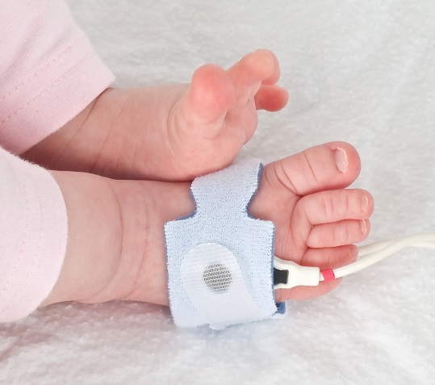

A major cost associated with screening will be the purchase of pulse oximeters and associated consumables. Hospitals and primary maternity birthing units will already have some pulse oximeters available, however equipment requirements are likely to be an issue for community-based midwives attending home births. Pulse oximeters cost approximately $1,300 but will be cheaper if purchased in bulk and if reusable sensors are used.

#### Recommendations

* **Use high-quality equipment and machine settings that can limit the number of false-positive test results.**
* **The DHB would be responsible for funding the equipment and providing the necessary consumables to support the implementation of pulse oximetry screening.**

## 5. Equity

Interventions designed to improve population health have the potential to benefit some groups more than others. Pulse oximetry screening may be most valuable in populations where the antenatal detection rate of CCHD is low. Implementing screening nationwide, to reach all newborn infants, is likely to achieve the greatest benefit and the most equitable outcomes.

Ensuring equity of access to the screening test will be a major challenge. The New Zealand feasibility study found that factors related to both the provider and participant were linked to whether a screening test occurred. Birth setting was significant, with the highest screening rates in a quaternary hospital and lowest rates in home births. Approximately 9% of births in New Zealand occur at a primary maternity unit and 4% at home. Another finding from the feasibility study was that not registering with a maternity care provider was associated with lower odds of infant screening (Cloete et al 2019).

Furthermore, the feasibility study found that only about half of Māori and Pacific babies were screened compared with three-quarters of Asian and European babies. Living in an area of socioeconomic deprivation was also associated with lower access to screening. Over a quarter of all women giving birth live in the most socioeconomically deprived areas of the country (Ministry of Health 2017). In contrast to the overall study findings, one region was able to achieve the same screening participation (no statistically significant difference) for all ethnic and socioeconomic groups. This indicates that with considered implementation, care providers can successfully engage with families to provide equitable access. The feasibility study concluded that the health gains are likely to be greater for Māori and Pacific babies and those living in the most deprived areas of New Zealand if equal participation in this screening can be achieved (Cloete et al 2019).

On this basis, the recommendation stemming from this research is that all newborn infants should receive access to POS, regardless of ethnicity, place of birth or other socioeconomic factors. To help achieve this, uniform guidelines should be developed to support the nationwide implementation of pulse oximetry screening (Pulse Oximetry Screening Steering Committee 2019).

Factors that may impact on equitable access to screening include:

* DHB engagement and adoption of the national guidelines
* midwifery workload and resourcing
* availability of pulse oximeters – equipment and consumables should be available to all those who perform the screening regardless of place of birth, including those who attend home births. The expectation is that this responsibility sits with DHBs.

#### Recommendations

* **Provide this screening to all newborn infants, addressing the significant inequities across the country.**
* **DHBs must consider their commitments to deliver equitable services and meet obligations under Te Tiriti o Waitangi during implementation.**
* **Consider including uptake of POS in national reporting so that equity can be monitored; for example, by adding POS to the Maternity Quality & Safety Programme reporting requirements.**

## 6. Monitoring

At its meeting in November 2019, the multidisciplinary working group agreed the following data should be collected to monitor quality and equity:

* has the test been done (uptake)
* saturation level for each test
* timing of the test (date/time of each test in relation to date/time of birth)
* pass or referral for further assessment
* declines and reason why
* outcomes of referred babies
* false-positives and false-negatives.

At this stage, it is expected that DHBs will undertake data collection and monitoring locally. We note that information may be documented electronically or manually, which will impact the timeliness of monitoring. A national information technology (IT) system is out of scope of this project. We recognise, however, that electronic data collection with an automated tool to calculate test results is ultimately the ideal IT solution.

Appendices Two and Three provide examples of case report forms that are currently used to collect this data.

#### Recommendation

* **Ministry of Health prescribes the minimum data collection required to ensure local monitoring of pulse oximetry screening.**

# Feedback questions

1. Do you have any feedback or concerns about the proposed screening algorithm **(see Appendix One)**?
2. What do you see as the implications or challenges related to implementing pulse oximetry screening in your DHB, and how do you propose to innovatively address these?
3. Do you have any further feedback on the recommendations in this discussion document?

# Appendix One: Screening algorithm

Well infant between 2 to 24 hours of age with a gestational age greater than or equal to 35 weeks. Perform screening test on left or right foot. (Screening should be performed prior to discharge/transfer from the place of birth.) Saturation greater than or equal to 95%: Pass, ensure clinical examination is also normal. Saturation less than 90%, refer for medical assessment. Saturation 90-94%, are there any clinical concerns? If yes, clinical concerns at any stage warrant immediate referral. If no, repeat test in 1 to 2 hours. Saturation greater than or equal to 95%: Pass, ensure clinical examination is also normal. Saturation less than 90%, refer for medical assessment. Saturation 90-94%, are there any clinical concerns? If yes, clinical concerns at any stage warrant immediate referral. If no, repeat test in 1 to 2 hours. If saturation is greater than or equal to 95%, pass, ensure clinical examination is also normal. If saturation is less than or equal to 94%, refer for medical assessment. 

# Appendix Two: Example case report form (A)

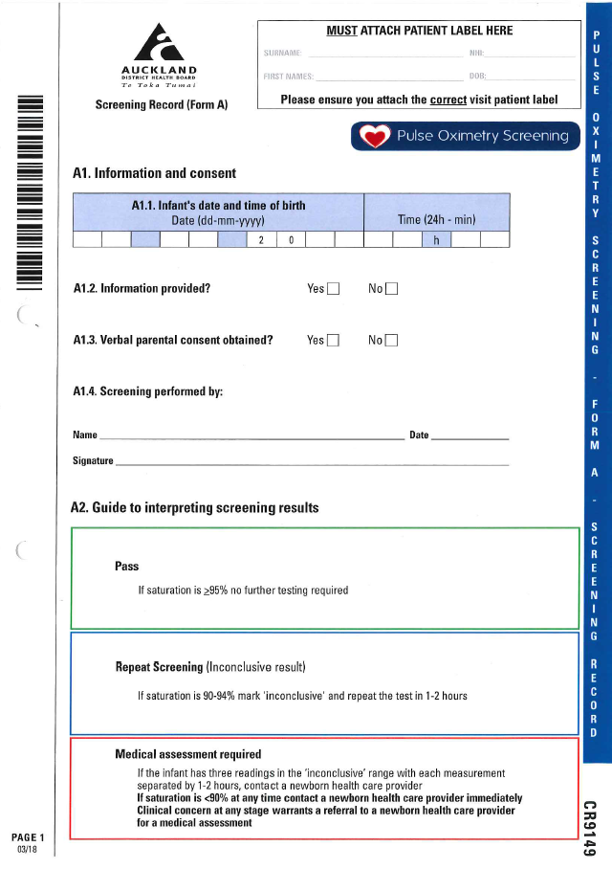

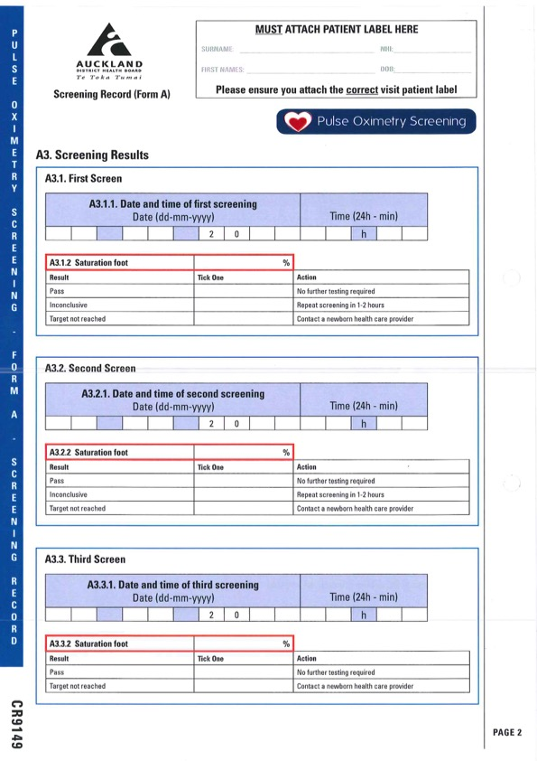

# Continuation of a scan of form A.Appendix Three: Example case report form (B)

Continuation of a scan of form A.

Continuation of a scan of form A.

# References

Ades AM, Dominguez TE, Nicolson SC, et al. 2010. Morbidity and mortality after surgery for congenital cardiac disease in the infant born with low weight. *Cardiology in the Young* 20(1): 8–17. DOI: 10.1017/S1047951109991909 (accessed 12 February 2021).

Arnold CL, Davis TC, Humiston SG, et al. 2006. Infant hearing screening: stakeholder recommendations for parent-centered communication. *Pediatrics* 117(5 Pt 2): S341–54. DOI: 10.1542/peds.2005-2633N (accessed 12 February 2021).

Bakr AF, Habib HS. 2005. Combining pulse oximetry and clinical examination in screening for congenital heart disease. *Pediatric Cardiology* 26(6): 832–5. DOI: 10.1007/s00246-005-0981-9 (accessed 12 February 2021).

Cloete E, Gentles T, Lutter R, et al. 2018. Consumer satisfaction with newborn pulse oximetry screening in a midwifery-led maternity setting. *International Journal of Neonatal Screening* 4(4): 38.

Cloete E, Gentles TL, Dixon LA, et al. 2019. Feasibility study assessing equitable delivery of newborn pulse oximetry screening in New Zealand's midwifery-led maternity setting. BMJ Open 9(8): e030506. DOI: 10.1136/bmjopen-2019-030506 (accessed 12 February 2021).

Cloete E, Bloomfield FH, Cassells SA, et al. 2020a. Newborn pulse oximetry screening in the context of a high antenatal detection rate of critical congenital heart disease. *Acta Paediatrica* 109(1): 93–9. DOI: 10.1111/apa.14946 (accessed 12 February 2021).

Cloete E, Gentles TL, Webster DR, et al. 2020b. Pulse oximetry screening in a midwifery-led maternity setting with high antenatal detection of congenital heart disease. *Acta Paediatrica* 109(1): 100–8*.* DOI: 10.1111/apa.14934 (accessed 12 February 2021).

de-Wahl Granelli A, Wennergren M, Sandberg K, et al. 2009. Impact of pulse oximetry screening on the detection of duct dependent congenital heart disease: a Swedish prospective screening study in 39,821 newborns. *BMJ* 338: a3037. DOI: 10.1136/bmj.a3037 (accessed 12 February 2021).

Ewer AK, Middleton LJ, Furmston AT, et al. 2011. Pulse oximetry screening for congenital heart defects in newborn infants (PulseOx): a test accuracy study*. The Lancet* 378(9793): 785–94. DOI: 10.1016/s0140-6736(11)60753-8 (accessed 12 February 2021).

Kluckow M. 2018. Barriers to the implementation of newborn pulse oximetry screening: a different perspective*.* International Journal of Neonatal Screening 4(1): 4. DOI: 10.3390/ijns4010004 (accessed 12 February 2021).

Koppel RI, Druschel CM, Carter T, et al. 2003. Effectiveness of pulse oximetry screening for congenital heart disease in asymptomatic newborns. *Pediatrics* 111(3): 451–5.

Meberg A. 2015. Newborn pulse oximetry screening is not just for heart defects. *Acta Paediatrica* 104(9): 856–7. DOI: 10.1111/apa.13082 (accessed 12 February 2021).

Ministry of Health. 2017. *Report on Maternity 2015*. Wellington: Ministry of Health. URL: <https://www.health.govt.nz/publication/report-maternity-2015> (accessed 12 February 2021).

Moody L, Choudhry K. 2013*.* Parental views on informed consent for expanded newborn screening. *Health Expectations* 16(3): 239–50. DOI: 10.1111/j.1369-7625.2011.00710.x (accessed 12 February 2021).

Oster ME, Kuo KW, Mahle WT. 2014. Quality improvement in screening for critical congenital heart disease. *Journal of Pediatrics* 164(1): 67–71 e62. DOI: 10.1016/j.jpeds.2013.08.044 (accessed 12 February 2021).

Pflugeisen BM, Amoroso PJ, Zook D, et al. 2015. Quality improvement measures in pulse-oximetry newborn heart screening: a time series analysis*.* *Pediatrics* 135(2): e531–9. DOI: 10.1542/peds.2014-1299 (accessed 12 February 2021).

Plana MN, Zamora J, Suresh G, et al. Pulse oximetry screening for critical congenital heart defects. *Cochrane Database Syst Rev*, 2018, Issue 3, Art. No. CD011912. DOI: 10.1002/14651858.CD011912.pub2 (accessed 12 February 2021).

Pulse Oximetry Screening Steering Committee. 2019. *Newborn Pulse Oximetry Screening in New Zealand:* *Feasibility study steering committee report and recommendations.* Auckland: Liggins Institute. URL: <https://www.auckland.ac.nz/en/liggins/our-research/reports-and-guidelines.html> (accessed 12 February 2021).