Indicative Allocation of Stores Across New Zealand (Maps) | January 2023

We have provided a series of maps by region, showing how tobacco retailers could be spread across New Zealand. These maps provide an idea of how many stores there might be in any urban or rural area. The aim is to give a general sense of what the bigger picture might be, so that people can provide feedback. Each pin on a map represents one store. The pins are only general locations (not existing stores) as no decisions have been made yet.

The final number of retailers and where they are located will take into account your feedback and also depend on who applies.

The scenario that was used to generate these numbers and maps was designed to ensure reasonable access for people who smoke in both urban and rural areas. For a detailed breakdown of how this scenario has been put together, please see the “Proposals for the Smoked Tobacco Products Regulatory Regime” consultation document, Section 1A.
Northland Region
Urban Area | Number of stores | 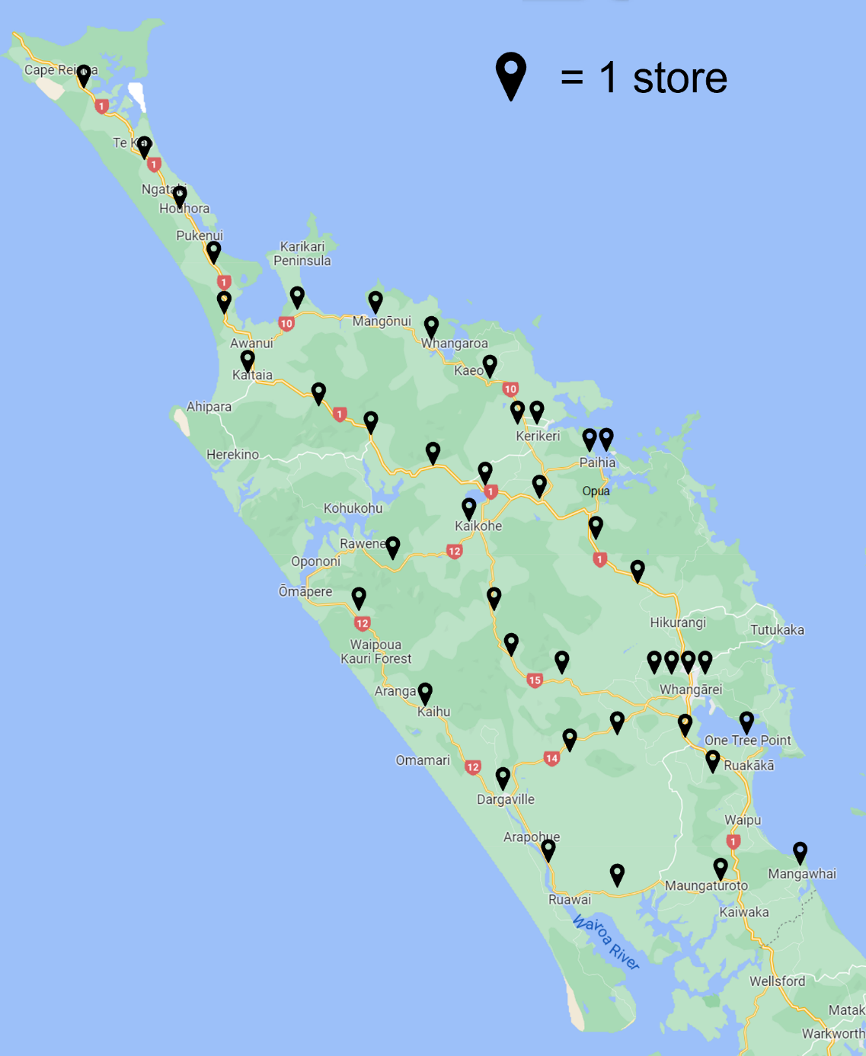  (Image source: Google maps)
Whangārei | 4
Kerikeri | 2
Paihia/Kawakawa/Moerewa | 2
Kaitaia | 1
Dargaville | 1
Kaikohe | 1
One Tree Point | 1
Ruakākā | 1
Mangawhai Heads | 1
Rural | 28
Total | 42
Auckland Region
Urban Area | Number of stores | 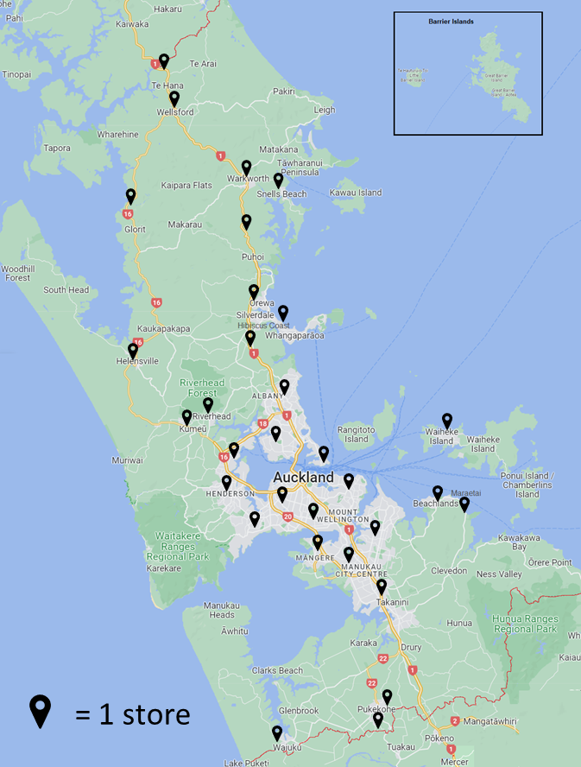
Auckland | 13
Hibiscus Coast | 3
Pukekohe | 2
Waiuku | 1
Waiheke West | 1
Beachlands-Pine Harbour | 1
Warkworth | 1
Kumeū-Huapai | 1
Snells Beach | 1
Riverhead | 1
Helensville | 1
Maraetai | 1
Wellsford | 1
Rural | 5
Total | 33
(Image source: Google maps)
Waikato Region
Urban Area | Number of stores | Urban Area | Number of stores | 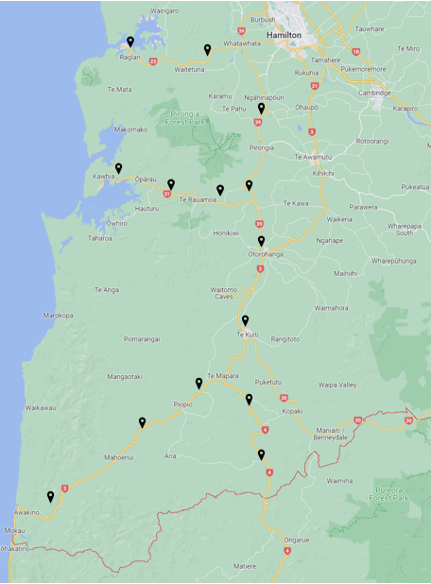  (Image source: Google maps)
Hamilton | 5 | Paeroa | 1
Taupō | 2 | Putāruru | 1
Cambridge | 2 | Whangamatā | 1
Tokoroa | 2 | Turangi | 1
Te Awamutu | 2 | Raglan | 1
Huntly | 1 | Otorohanga | 1
Matamata | 1 | Kihikihi | 1
Morrinsville | 1 | Te Kauwhata | 1
Ngāruawāhia | 1 | Coromandel | 1
Thames | 1 | Rural | 53
Whitianga | 1
Waihi | 1
Tuakau | 1
Pōkeno | 1
Te Kuiti | 1
Te Aroha | 1 | Total | 86
Waikato Region (continued)
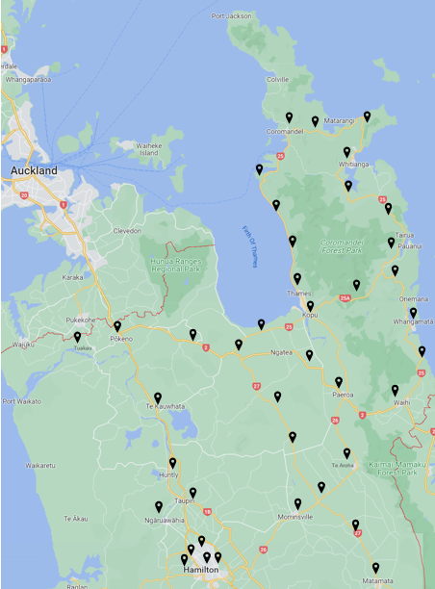  (Image source: Google maps) | 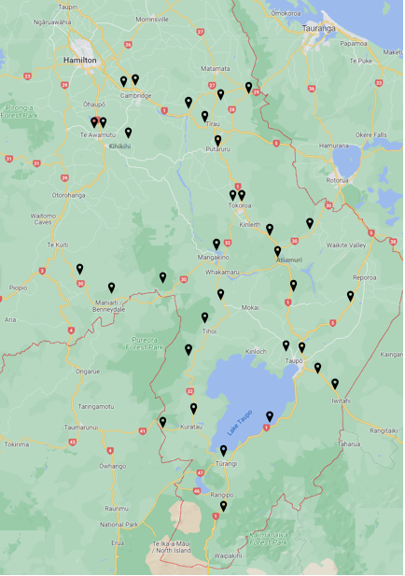  (Image source: Google maps)
Bay of Plenty Region
Urban Area | Number of stores | 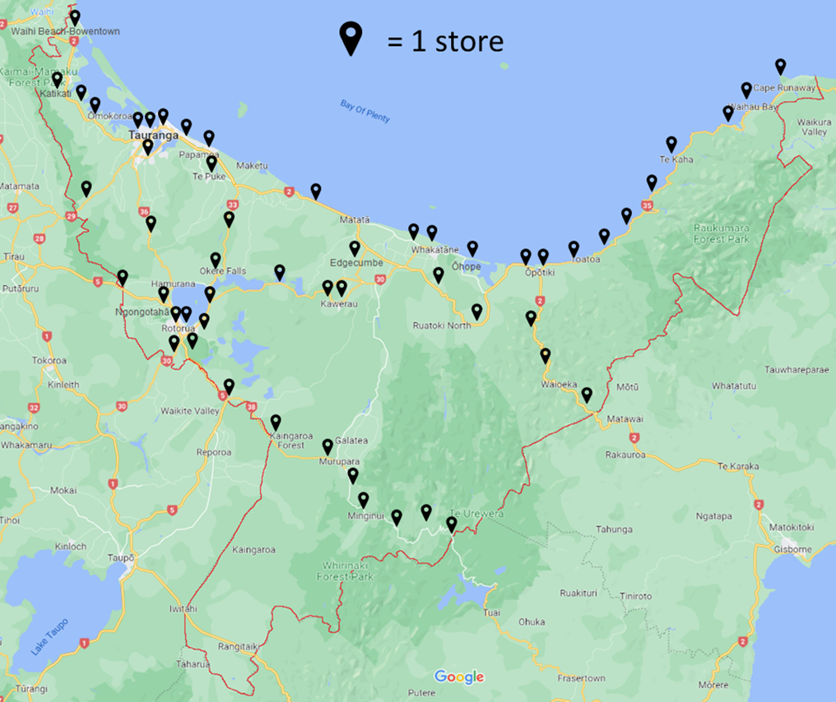  (Image source: Google maps)
Tauranga | 5
Rotorua | 4
Whakatāne | 2
Te Puke | 1
Kawerau | 2
Katikati | 1
Ngongotahā | 1
Ōpōtiki | 2
Omokoroa | 1
Ōhope | 1
Waihi Beach-Bowentown | 1
Murupara | 1
Edgecumbe | 1
Rural | 33
Total | 56

Tairawhiti Region
Urban Area | Number of stores | 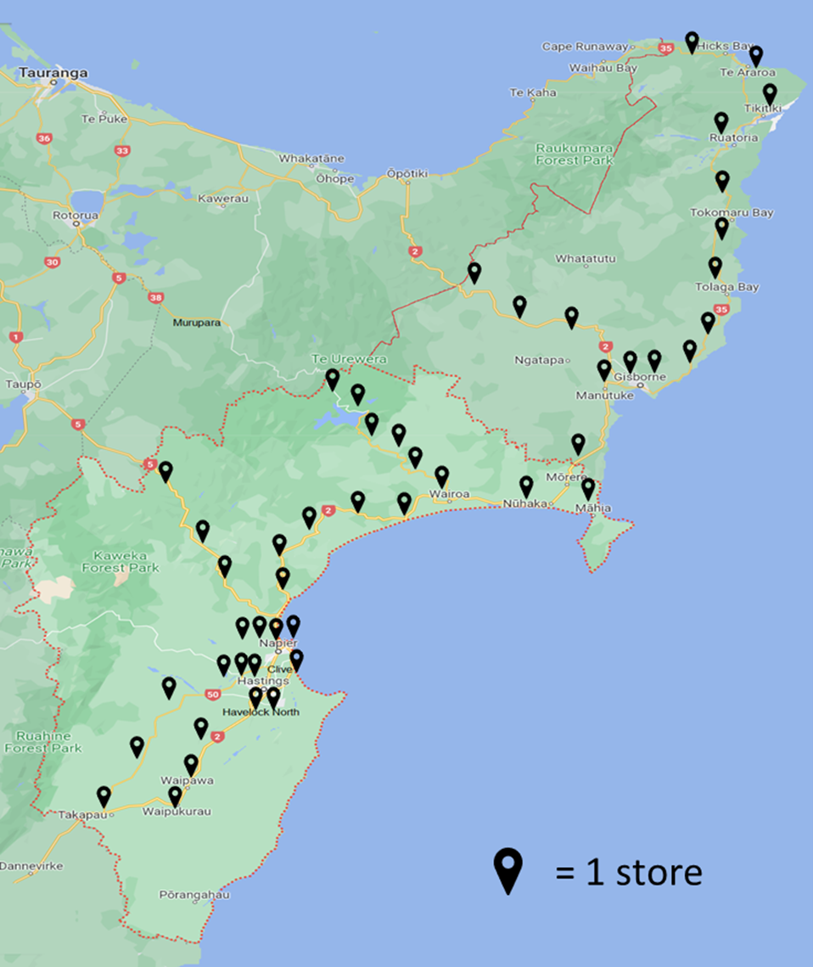
Gisborne | 3
Napier | 4
Hastings | 3
Havelock North | 2
Wairoa | 1
Waipukurau | 1
Clive | 1
Waipawa | 1
Rural | 32
Total | 48
(Image source: Google maps)
Manawatū-Whanganui Region
Urban Area | Number of stores | 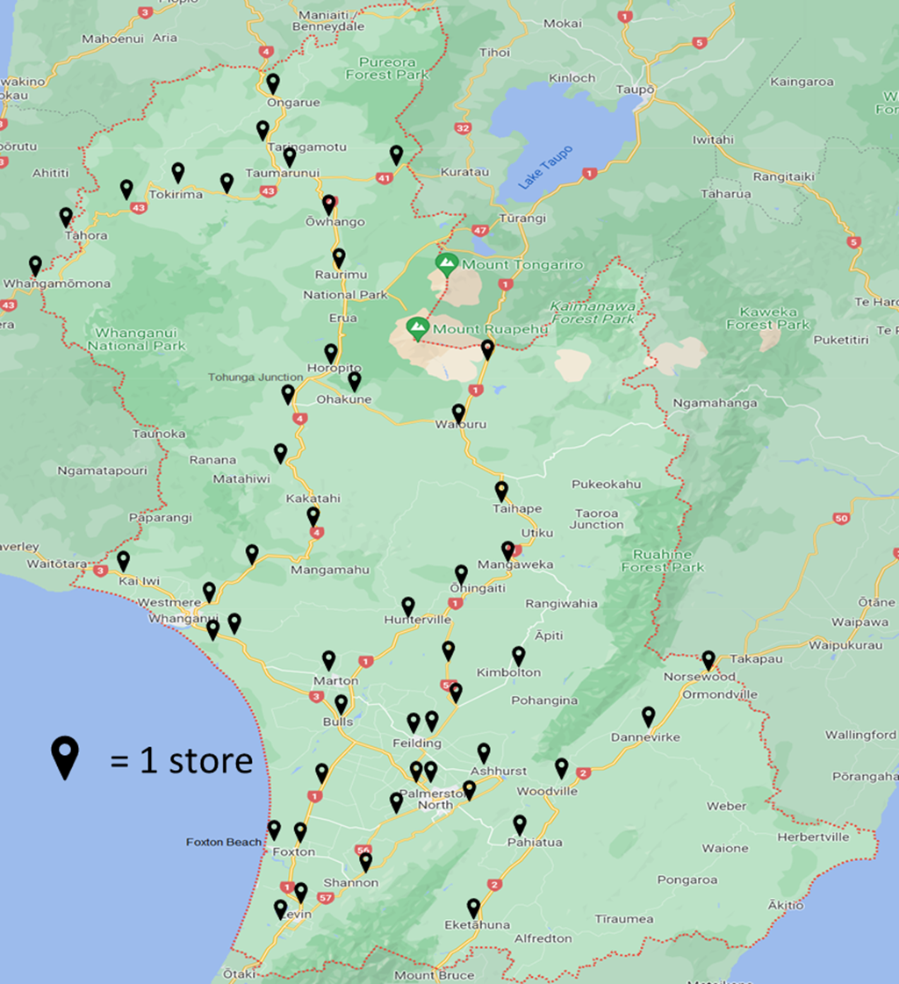  (Image source: Google maps)
Bulls | 1
Foxton Beach | 1
Palmerston North | 4
Whanganui | 3
Levin | 2
Fielding | 2
Dannevirke | 1
Marton | 1
Taumarunui | 1
Foxton | 1
Ashurst | 1
Pahiatua | 1
Taihape | 1
Rural | 30
Total | 50
Taranaki Region
Urban Area | Number of stores | 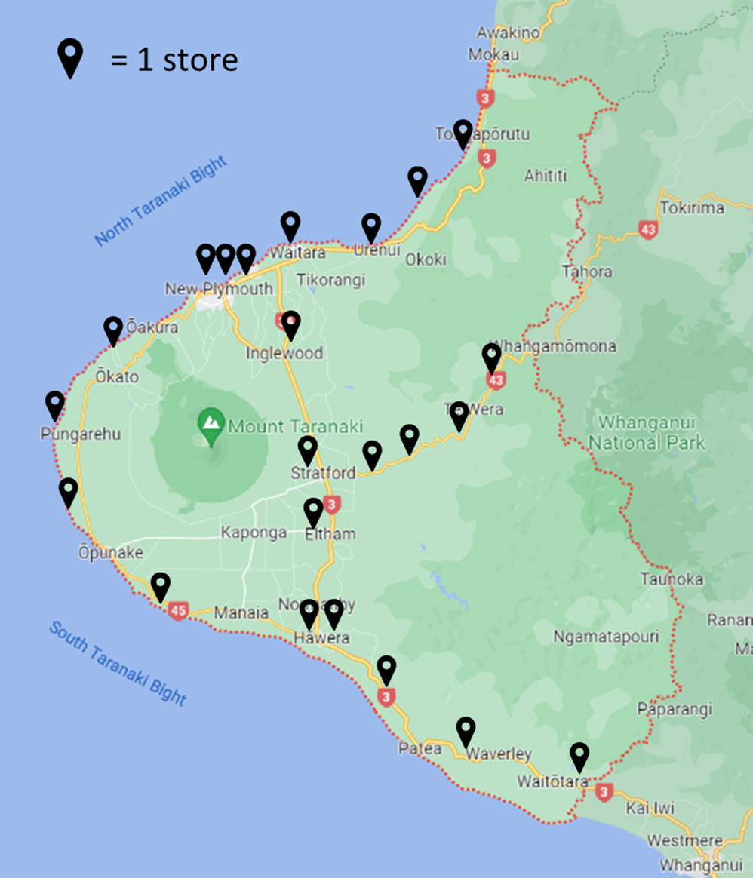
New Plymouth | 3
Hāwera | 2
Waitara | 1
Stratford | 1
Inglewood | 1
Eltham | 1
Rural | 13
Total | 22
(Image source: Google maps)

Wellington Region
Urban Area | Number of stores | 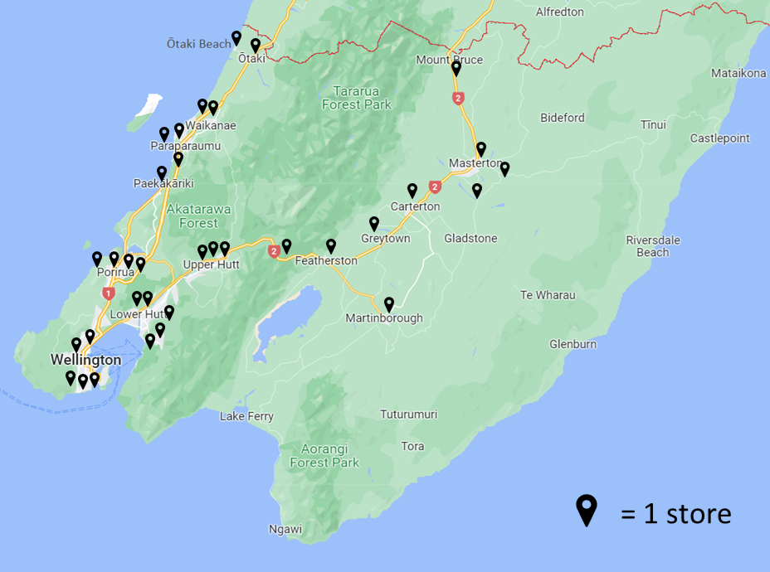  (Image source: Google maps)
Wellington | 5
Lower Hutt | 5
Porirua | 4
Upper Hutt | 3
Paraparaumu | 2
Masterton | 2
Waikanae | 2
Carterton | 1
Ōtaki | 1
Greytown | 1
Featherston | 1
Ōtaki Beach | 1
Martinborough | 1
Paekākāriki | 1
Rural | 2
Total | 32
Nelson-Marlborough Region
Urban Area | Number of stores | 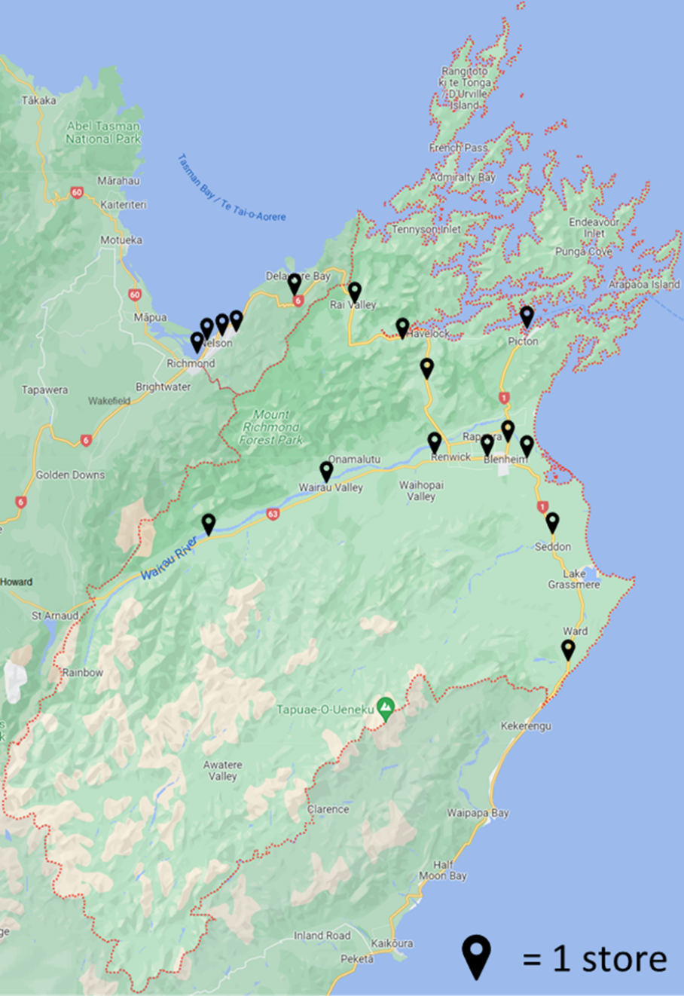  (Image source: Google maps)
Blenheim | 2
Picton | 1
Renwick | 1
Nelson | 3
Rural | 10
Total | 17
Tasman-West Coast Region
Urban Area | Number of stores | 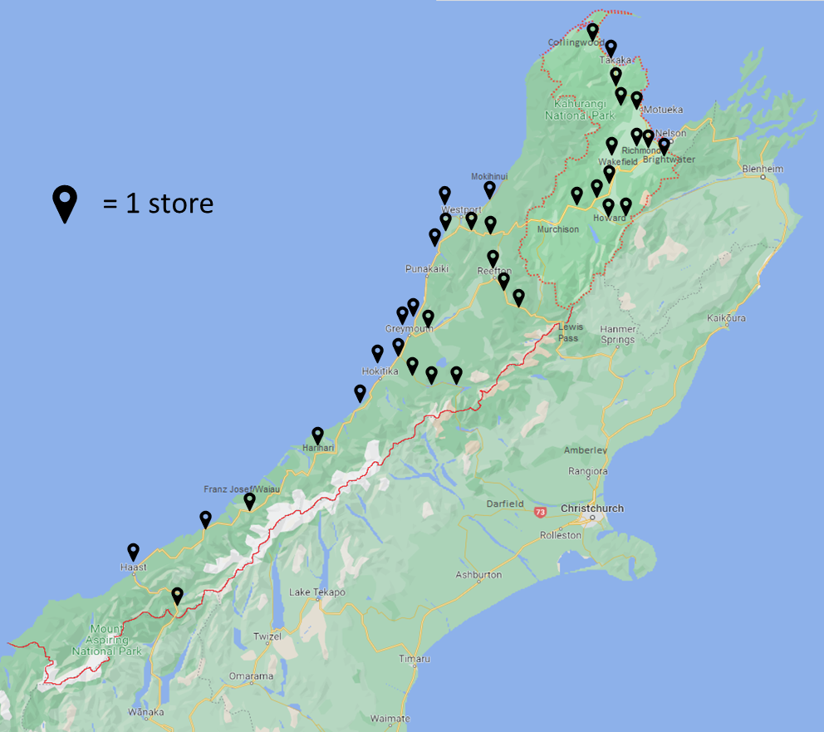  (Image source: Google maps)
Richmond | 2
Motueka | 1
Wakefield | 1
Brightwater | 1
Greymouth | 2
Westport | 1
Hokitika | 1
Rural | 38
Total | 47

Canterbury Region
Urban Area | Number of stores | 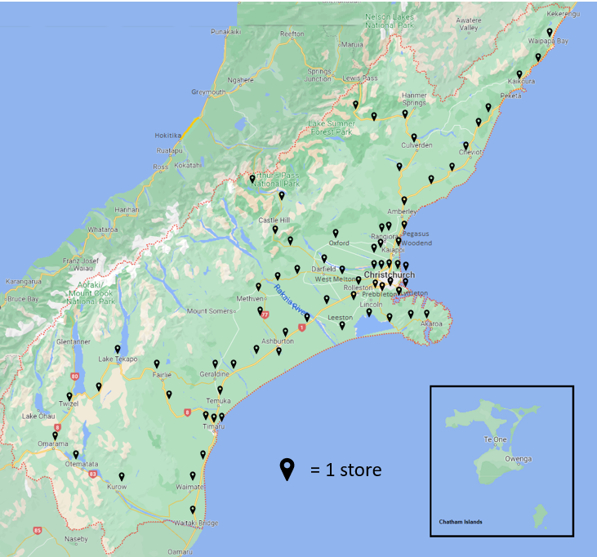  (Image source: Google maps)
Christchurch | 8
Timaru | 3
Rolleston | 2
Ashburton | 2
Rangiora | 2
Kaiapoi | 2
Lincoln | 1
Prebbleton | 1
Temuka | 1
Pegasus | 1
Waimate | 1
Woodend | 1
Lyttleton | 1
Darfield | 1
Geraldine | 1
West Melton | 1

Canterbury Region (continued)
Urban Area | Number of stores | 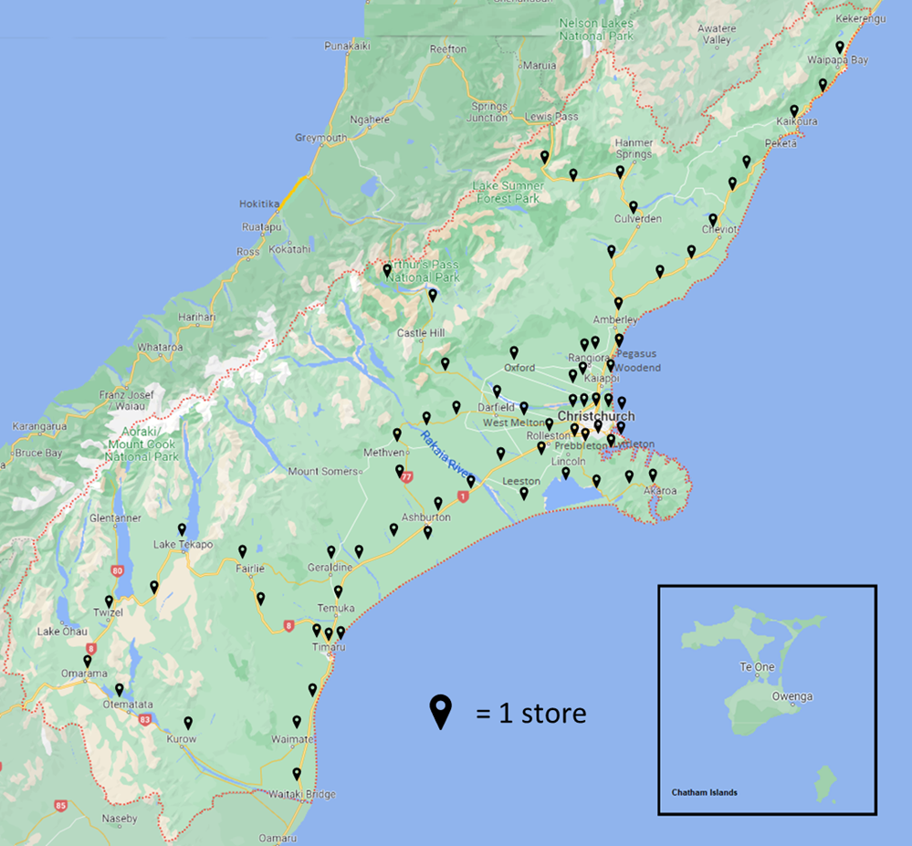  (Image source: Google maps)
Kaikōura | 1
Oxford | 1
Leeston | 1
Amberley | 1
Methven | 1
Rural | 36
Total | 70

Otago-Southland Region
Urban Area | Number of stores | 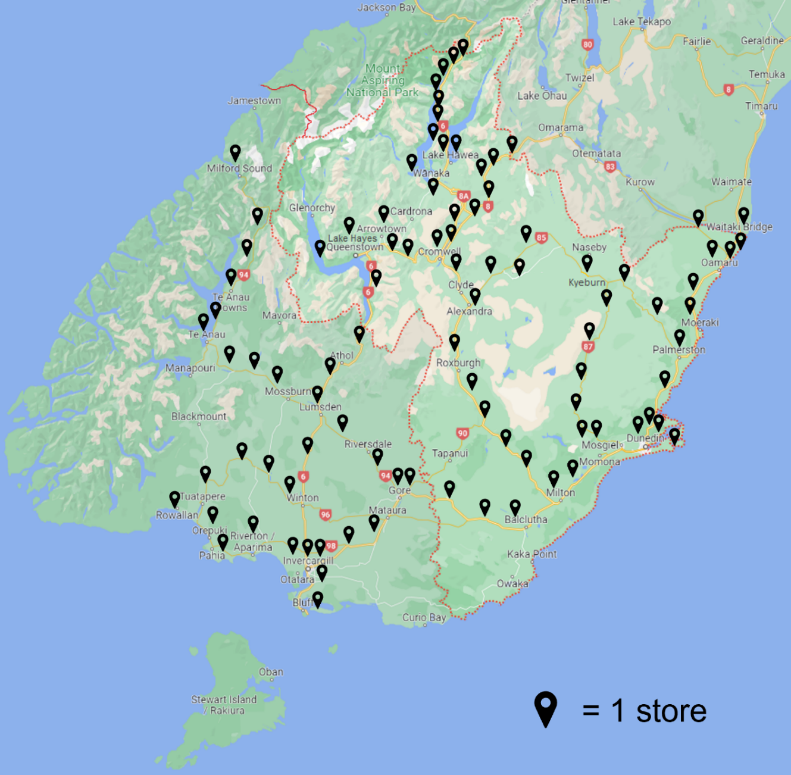  (Image source: Google maps)
Dunedin | 4
Queenstown | 2
Mosgiel | 2
Oamaru | 2
Wanaka | 1
Lake Hayes | 1
Cromwell | 1
Alexandra | 1
Balclutha | 1
Arrowtown | 1
Milton | 1
Lake Hāwea | 1
Invercargill | 4
Gore | 2
Te Anau | 1
Winton | 1
Bluff | 1
Rural | 67
Total | 94

January 2023
HP 8659

